Sanner’s Carbine Classic July Match Report
7/29/2023
Few would deny that St. Mary’s County is a gorgeous place, but that beauty comes at a price during the summer. The week leading up to the July 2023 Sanner’s Carbine Classic was monstrously hot. As a result, the five stages of the match were simplified in order to ease the burden of setup and tear down and try to move shooters through the match expeditiously.

However, “simplified” did not mean “easy”. Forty-four shooters were pitted against portholes, shoulder transitions, mandatory body and head shots, and two different limited round count stages, each presenting unique variations on the age-old question of speed versus accuracy.

As the match cooled off and the heat picked up the overall winner was David Metcalfe who, despite his blistering speed was only two points down for the entire match. Great shooting! Category and divisional winners are listed below.

High Categories:
High Junior: Joseph Murphy
High Senior: Glenn Kahler
High Lady: Andrea Swierczek
High Active Duty: Jeff Tuckey

Divisional Winners:
Dot: Mark Swierczek
Ironman: Tim Kelly
PCC: David Metcalfe
Prepper: Anibal Delgado
Scope: James Foreman

Additionally, a special shout-out must be given to our competitors in Prepper division. Despite the blazing heat and suffocating humidity this match featured nine shooters in that division; the largest showing of Prepper shooters since the division was added!

Below is the link for the match results on Practiscore, as well as some photos from the match on the following pages.

https://practiscore.com/results/new/212821

The next match will be on Saturday, September 30th. As usual, look for sign-ups a few weeks in advance.
See you then!

-Jake Swierczek, Jeremy Hanson, and Anibal Delgado

A full house for the all-important pre-match safety brief:
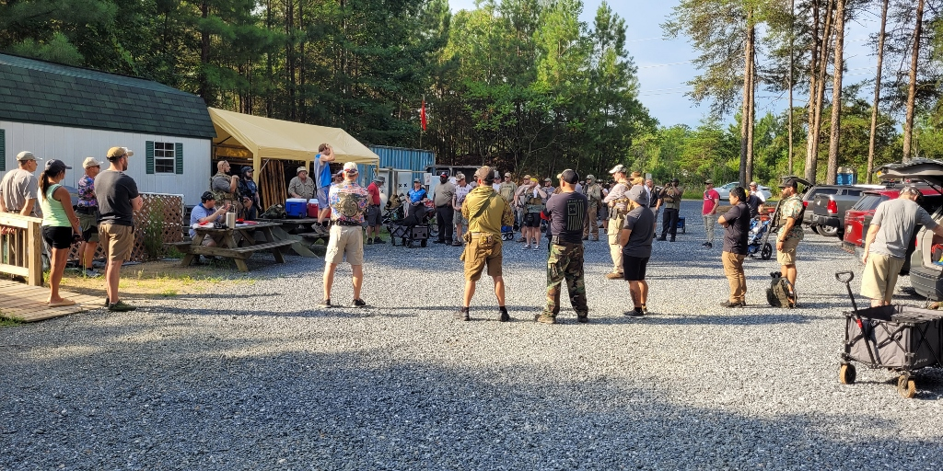

Shooting through the balistraria:
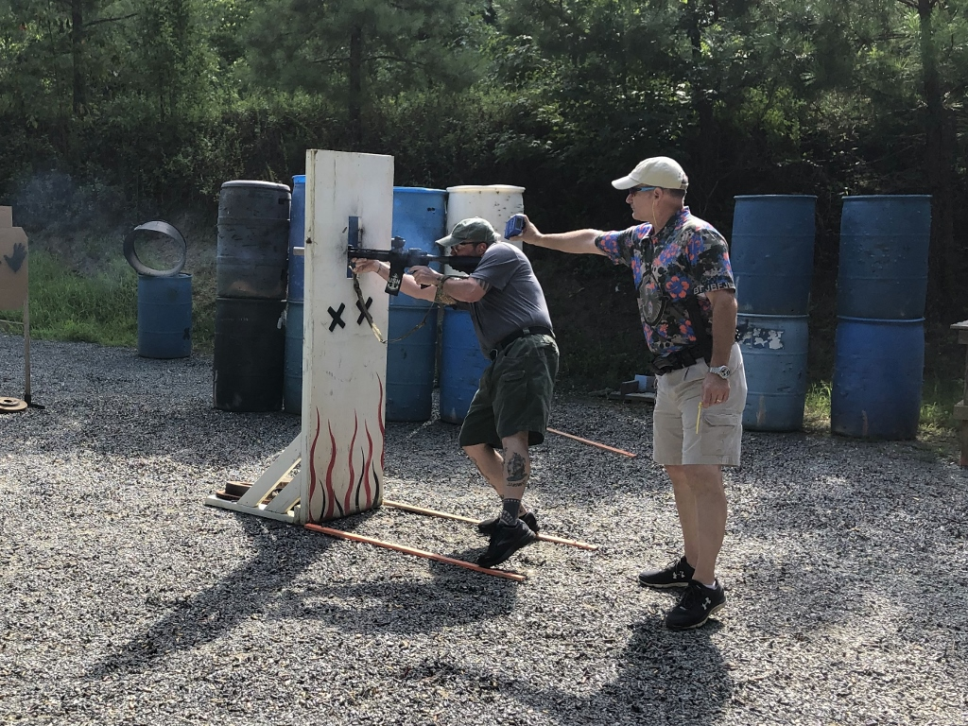

Those AK’s are LOUD!
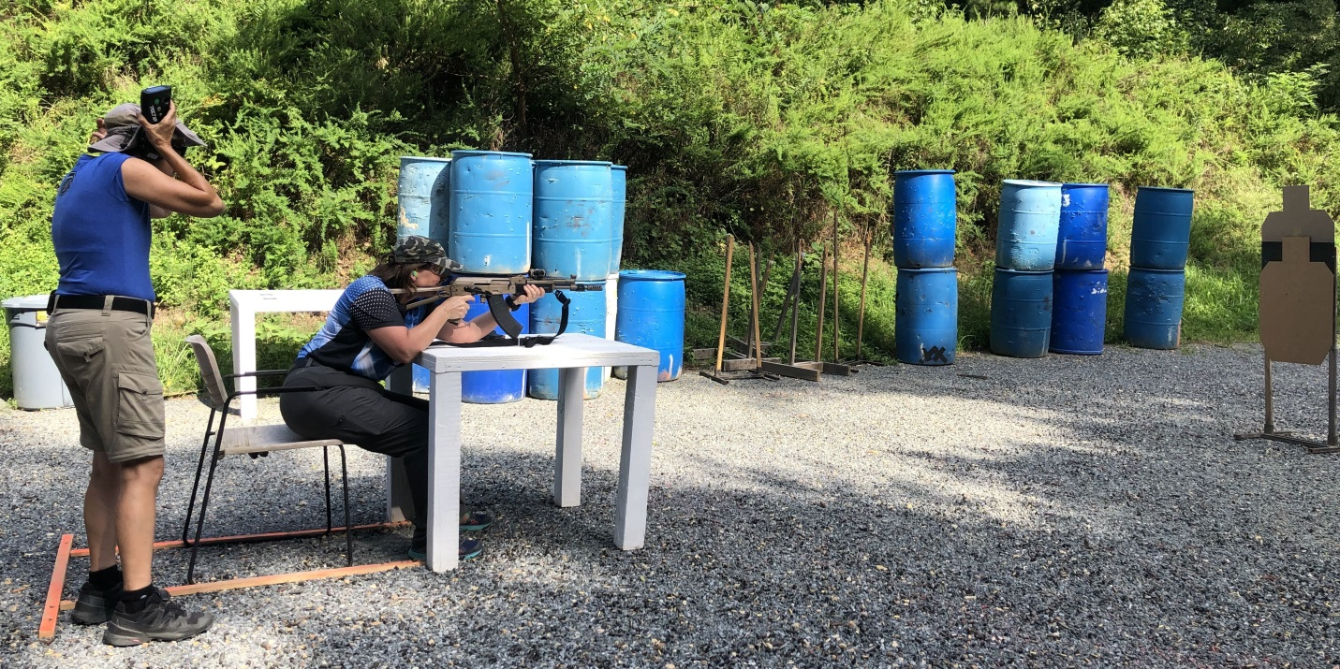

Motivated shooters and attentive RSO’s are what make this match work!
