Sanner’s Carbine Classic May Match Report
5/21/2022

The May Carbine Classic match was a warm summer welcome to all shooters new and seasoned. The morning started nicely, but temperatures quickly rose to a healthy 90+ keeping the rifles hot and the action hotter.

Stages for this match came from the IDPA state match, though unfortunately we did not get to use the electronic systems they do. Despite this, stages still presented fun and practical challenges including some tight hallway problems, as well as shooting from within a car! As we move forward these stages will definitely inspire more interesting designs, and the electronics may make an appearance sooner rather than later.

This time around Prepper division did not have quite the turnout as previous matches, I suspect the heat turned prospective preppers away, but a core three held the torch as well as all their gear and equipment they needed for the match on their person throughout the entire match! This included their rifles, plenty of water, food, ammunition, spare parts, etc. Congratulations to every prepper for completing the match but a special congratulations go to James Paishon for winning prepper division!

Overall, though, it was David Metcalfe once again taking the overall win, edging out the next competitor by nearly 12 seconds, with a PCC no less!

Additional recognition must be given to Jack Perrin as not only being the top Active Duty competitor but coming in second place overall!

Joseph Paul took the honors of top Junior, Gary Turner ended up as the high senior, and Andrea Swierczek as the high lady! Great shooting!

Included below is the link to the scores posted on Practiscore and below that are a few photos snagged during the match.

https://practiscore.com/results/new/168338

The next match will be July 30th; as usual sign-ups will be announced a couple weeks in advance.

-Jake Swierczek

Shooting from inside a car can be very disorienting, always good to practice it when able!

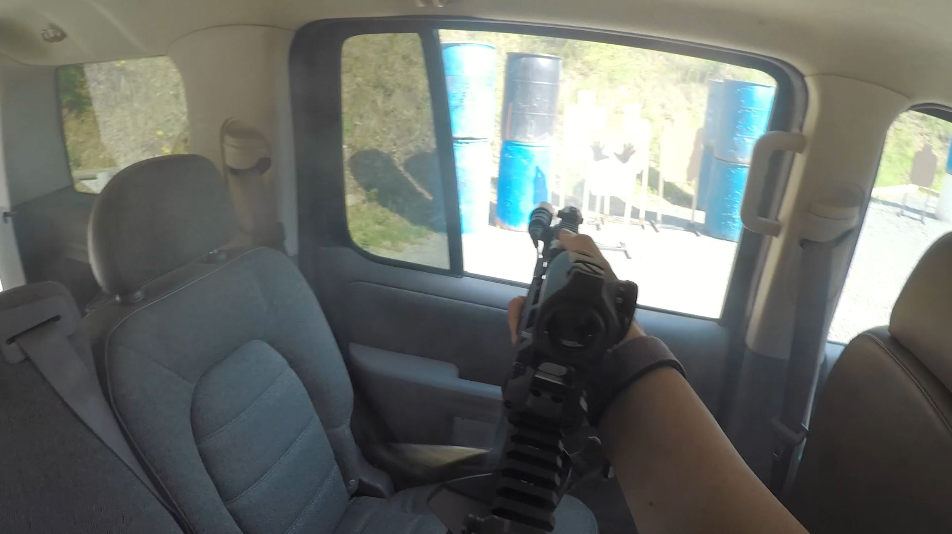

Getting over to the window can help make it easier, especially when engaging contact front

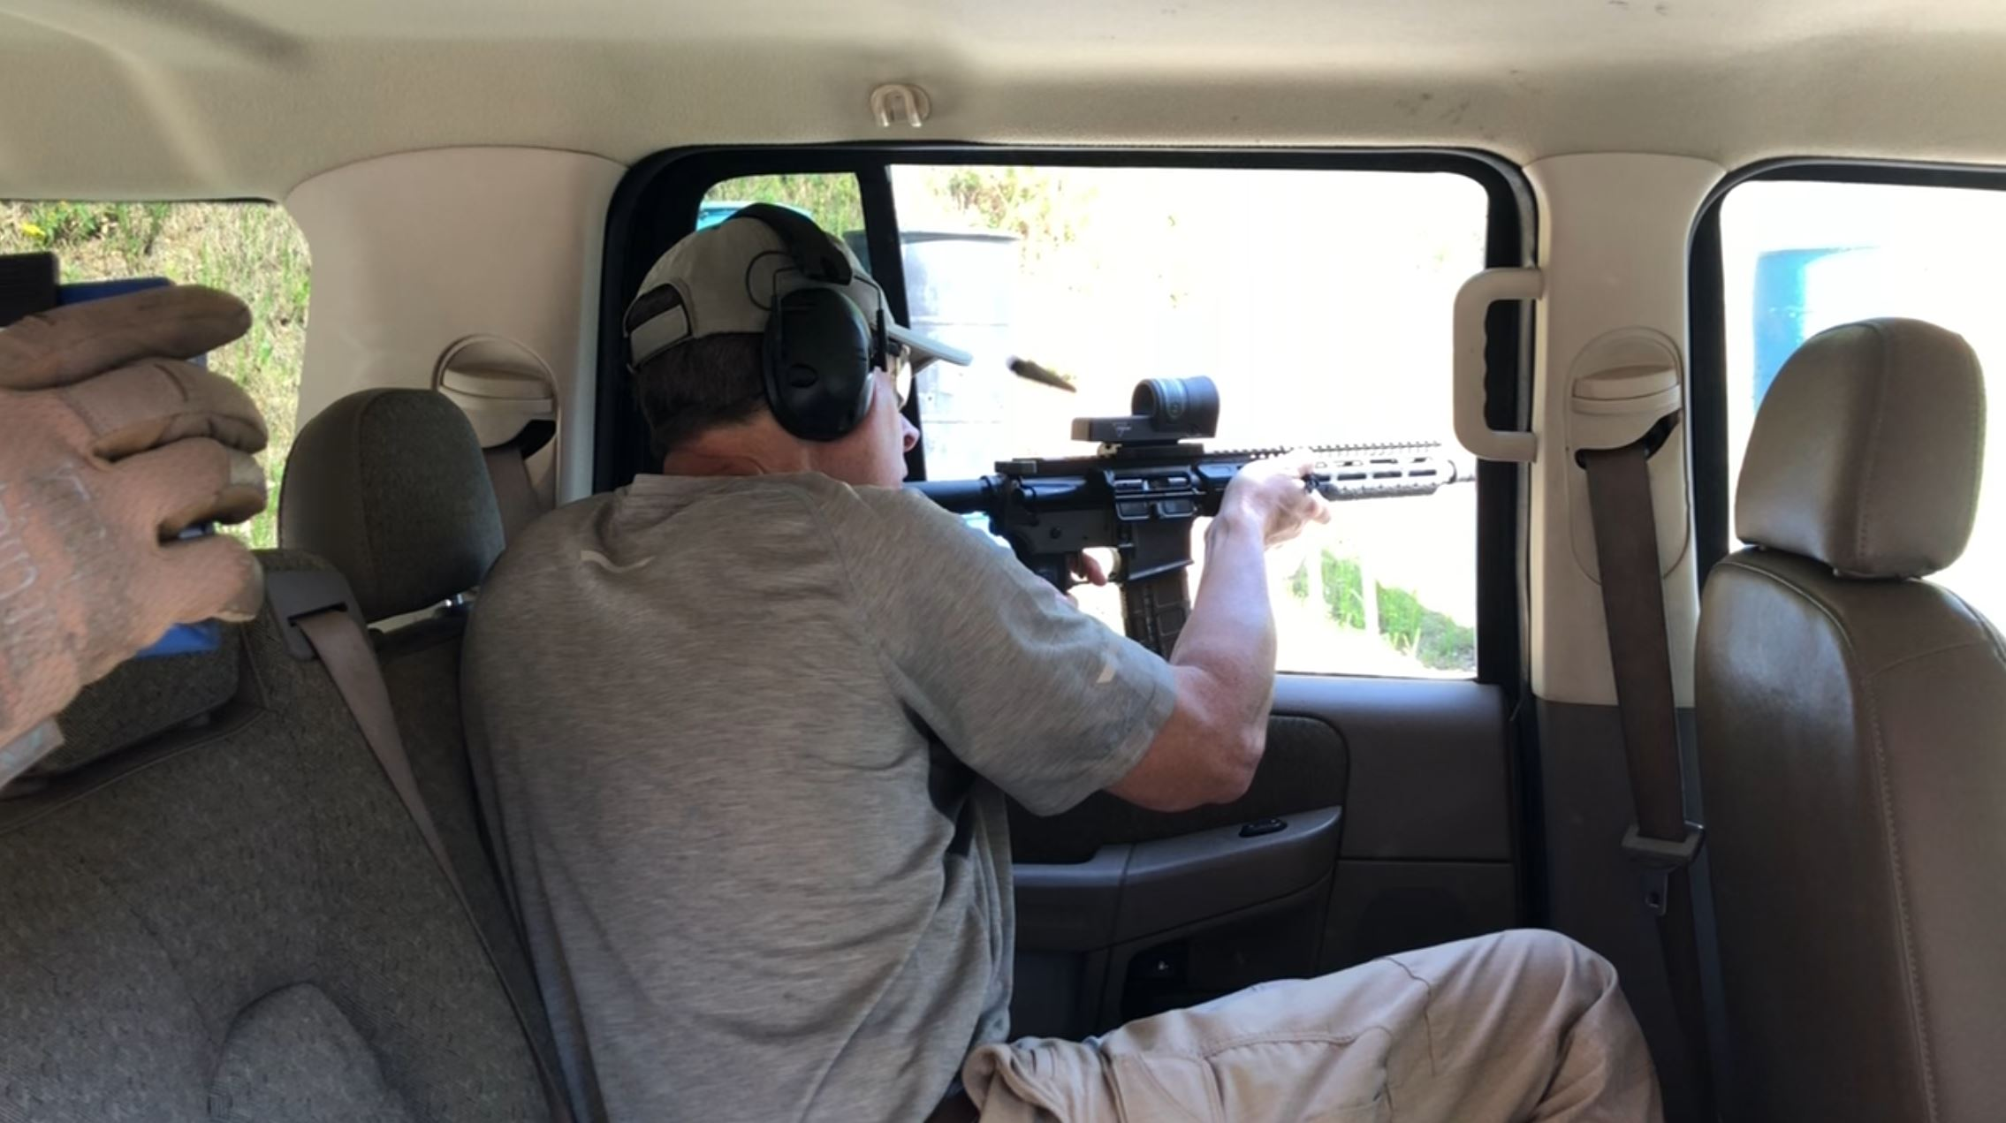

However, moving in the car with kit is easier said than done

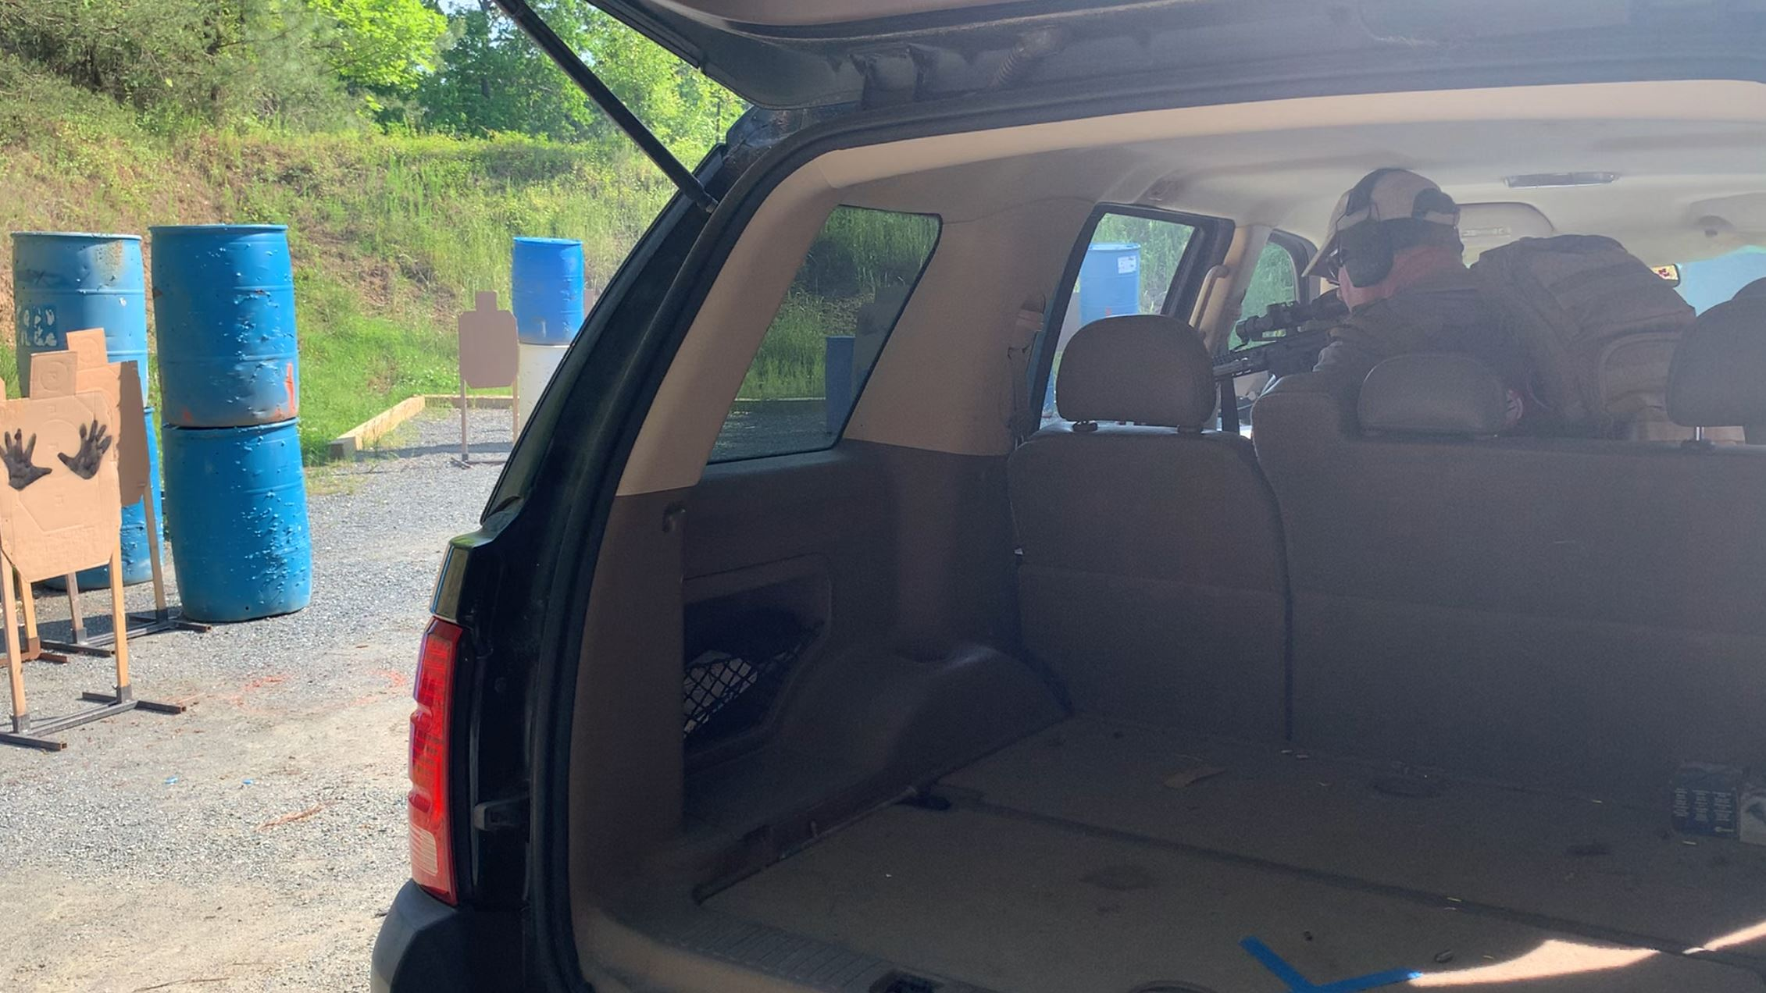

Medusa Joe seen here burning down the stage with a classic Camp 9!

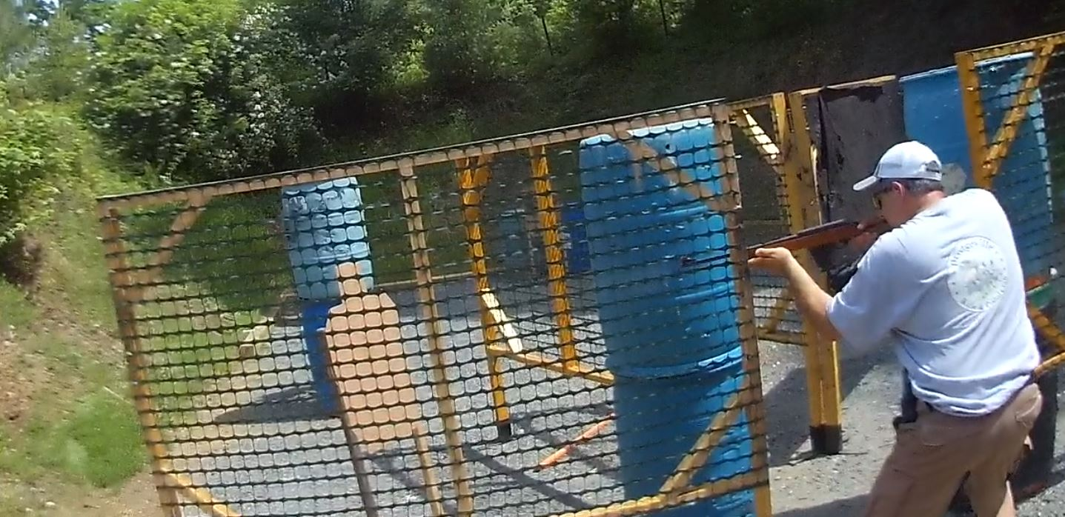

Talk about driving the gun!

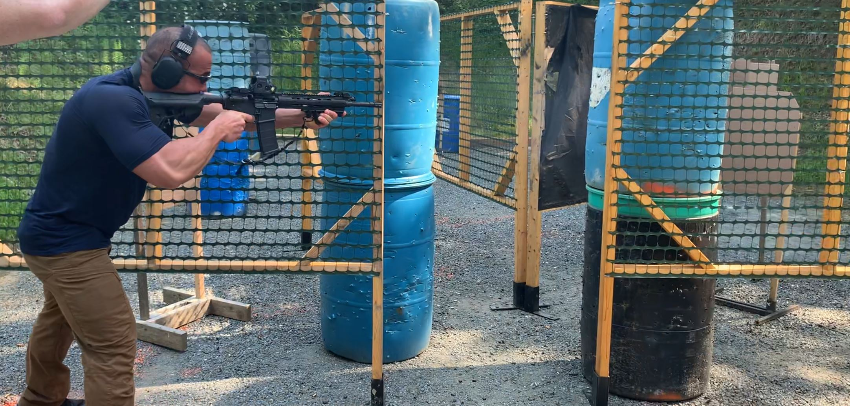

Even the enemy rifles performed well:

