Sanner’s Lake Frozen Chosin Match Report
01/28/23

The day dawned with temperatures just cresting above the freezing mark as a stalwart band of competitors made their way to the Sanner’s Lake rifle range for the eighth annual Frozen Chosin match. As the sun rose higher in the sky, though, the conditions took a marked turn for the better...hardly representative of the grueling conditions at the actual Battle of Chosin Reservoir, but it sure made for perfectly pleasant conditions under which to shoot a rifle match!

The battle for the top spot was tight but it came down to the final string of standing slow fire to determine the victor, with James Black and his Garand taking first place overall with an excellent 256-3X, edging out Jeremy Hanson and his Garand rolling into second place with an superb 250-3X. Right behind them Greg Banta’s M1 Carbine was nipping at their heels, finishing strong with a well-shot 248-1X to take third place overall as well as top M1 Carbine! Amongst the enemy rifles it was the SVT-40 of Nathanial Swift keeping the heat on the allies, overcoming a minor malfunction during the rapid fire stage with some field-expedient percussive maintenance, jumping right back into the battle and cruising into fourth place with a crisp 234-2X. Congratulations to all the winners!

See a complete summary of the scores as well as pictures from the match below. Thanks to everybody for making it to the range regardless of the balmy weather and keeping the action fast and furious! Keep an eye on the Sanner’s club calendar as we get closer to the “regular season” of matches starting in the March timeframe.

See you at the range!

The “Chosin Few”:
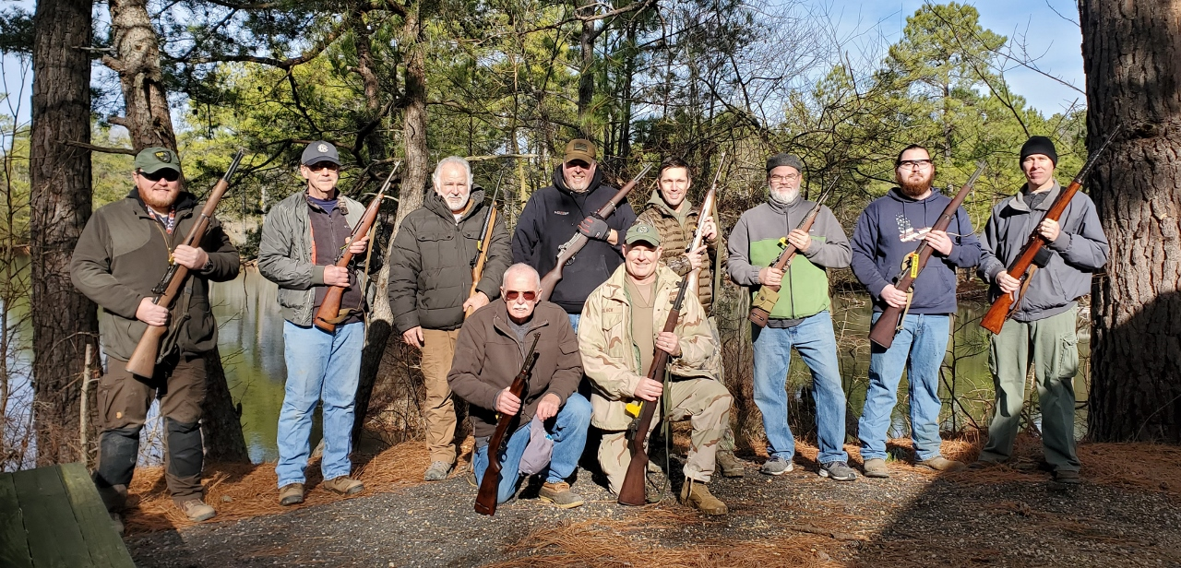

SR-1 Target 100 yards
Place | Name | Rifle | Caliber | Prone  Slow | X | Prone  Rapid | X | Standing  Slow | X | Total | X
1 | James Black | M1 Garand | .30-06 Springfield | 92 | 3 | 81 | 0 | 83 | 0 | 256 | 3
2 | Jeremy Hanson | M1 Garand | .30-06 Springfield | 91 | 1 | 92 | 1 | 67 | 1 | 250 | 3
3 | Greg Banta | M1 Carbine | .30 Carbine | 91 | 1 | 84 | 0 | 73 | 0 | 248 | 1
4 | Nathanial Swift | SVT-40 | 7.62x54R | 86 | 1 | 85 | 1 | 63 | 0 | 234 | 2
5 | Jonathan Ramsey | M1 Carbine | .30 Carbine | 78 | 1 | 86 | 0 | 56 | 0 | 220 | 1
6 | Alston Rush | M1 Carbine | .30 Carbine | 73 | 0 | 82 | 0 | 63 | 0 | 218 | 0
7 | Greg Banta | M1 Carbine | .30 Carbine | 86 | 0 | 73 | 0 | 59 | 0 | 218 | 0
8 | Pat Patton | M1 Carbine | .30 Carbine | 79 | 0 | 82 | 0 | 55 | 0 | 216 | 0
9 | Joshua Kelley | M1 Garand | .30-06 Springfield | 85 | 0 | 70 | 0 | 28 | 0 | 183 | 0
10 | Pat Patton | M1 Carbine | .30 Carbine | 55 | 0 | 53 | 1 | 27 | 0 | 135 | 1
11 | Draven Silks | M1 Garand | .30-06 Springfield | 16 | 0 | 59 | 0 | 8 | 0 | 83 | 0
12 | Dick Chadwick | M1 Carbine | .30 Carbine | 68 | 0 | 16 | 0 | withdrew, disabled rifle
300 total points possible. Ties broken by X's and then by highest standing score.

Wall to Wall Slow Fire:
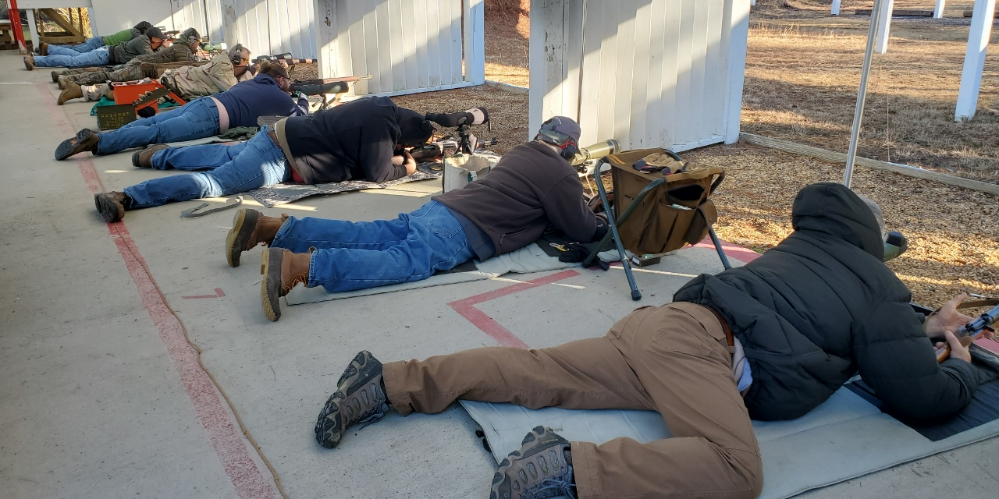

The Targets Tell the Tale: