The pleasant late summer/early fall weather brought a full firing line of competitors to the September rimfire sporter match at Sanner’s Lake, and the action was non-stop from start to finish! When the smoke finally cleared, it was a pair of Savage bolt-actions taking the top two spots followed closely by a pair of 10/22’s right behind them. See all the scores and details below. Our next match will be on October 8th, and the weather promises to get better and better, so be sure to get your rimfire rifle dialed in and join us at the range before the season ends. See you in October!
CMP B-19 Target 50/25yards
# | Name | Rifle | Action | Sights | Prone  Slow | X | Prone  Rapid | X | Sitting  Slow | X | Sitting  Rapid | X | Standing  Slow | X | Standing  Rapid | X | Total | X
1 | Jake Swierczek | Savage MkII BTV | Bolt | Scope | 100 | 6 | 98 | 5 | 98 | 5 | 97 | 2 | 99 | 4 | 97 | 4 | 589 | 26
2 | Matt Reider | Savage MkII FV-SR | Bolt | Scope | 98 | 3 | 95 | 0 | 95 | 1 | 93 | 2 | 98 | 2 | 87 | 0 | 566 | 8
3 | Butch Butchko | Ruger 10/22 | Semi | Scope | 95 | 2 | 95 | 2 | 95 | 1 | 90 | 0 | 89 | 1 | 86 | 1 | 550 | 7
4 | Andrea Swierczek | Ruger 10/22 | Semi | Scope | 93 | 1 | 97 | 4 | 89 | 0 | 90 | 2 | 90 | 2 | 89 | 0 | 548 | 9
5 | Greg Banta | Nordic 22 | Semi | Scope | 96 | 4 | 98 | 2 | 89 | 0 | 92 | 2 | 86 | 0 | 80 | 0 | 541 | 8
6 | Jeff Heisler | Ruger 10/22 | Semi | Scope | 91 | 2 | 92 | 3 | 88 | 2 | 88 | 1 | 92 | 1 | 83 | 1 | 534 | 10
7 | James Butchko III | Mossberg 715T | Semi | Scope | 88 | 0 | 78 | 0 | 85 | 0 | 81 | 2 | 94 | 1 | 89 | 0 | 515 | 3
8 | Tom Reider | CZ 455 American | Bolt | Scope | 90 | 2 | 61 | 0 | 88 | 1 | 84 | 0 | 86 | 1 | 81 | 0 | 490 | 4
600 total points possible. Ties broken by X count, then by highest standing rapid score.

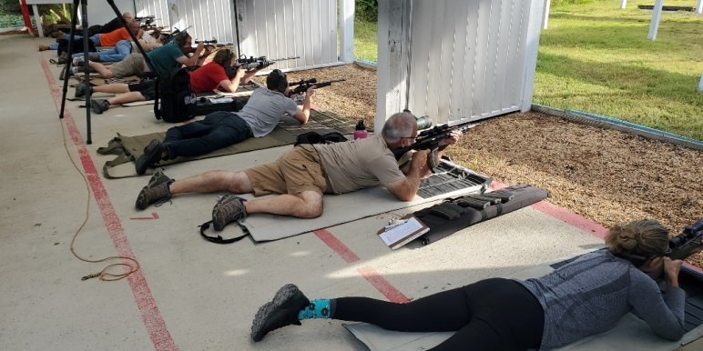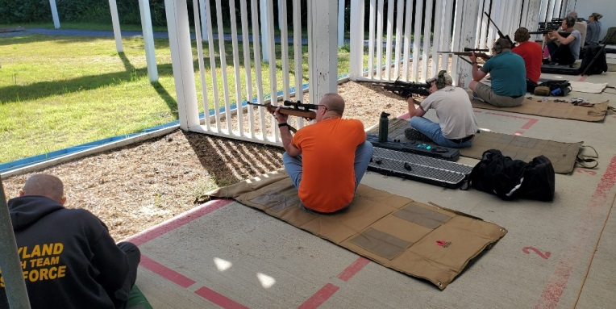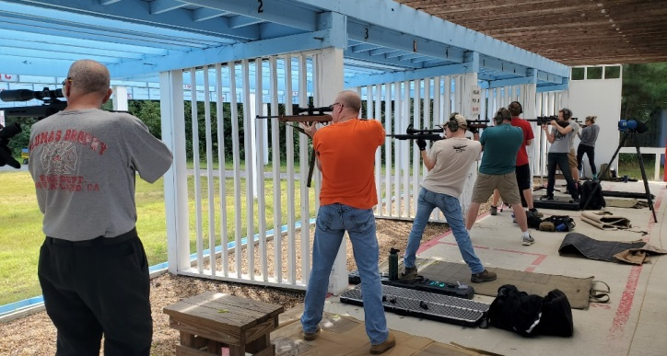

Notes:
Stage 1 = prone slow fire, 10 shots in 10 minutes, CMP B-19 target at 50 yards
Stage 2 = prone rapid fire, two strings of 5 shots in 30/25 seconds, CMP B-19 target at 50 yards
Stage 3 = sitting or kneeling slow fire, 10 shots in 10 minutes, CMP B-19 target at 50 yards
Stage 4 = sitting or kneeling rapid fire, two strings of 5 shots in 30/25 seconds, CMP B-19 target at 50 yards
Stage 5 = standing slow fire, 10 shots in 10 minutes, CMP B-19 target at 25 yards
Stage 6 = standing rapid fire, two strings of 5 shots in 30/25 seconds, CMP B-19 target at 25 yards

