Sanner’s Lake Woodstock Match Report – April 2022

Once again a crowded contingent of vintage military rifle buffs filled the firing lines at the April Woodstock match at Sanner’s Lake making for two nearly-full relays of classic battle rifles ...an excellent way to kick off the 2022 shooting season! The scores were super-tight up and down the board, with lots of tie breakers needed to sort out the final results. We even had dedicated benchrest shooter Steve Reimers show up with his bedded/accurized ’03 Springfield and lay down some record-breaking scores...but of course his modified rifle was ineligible for the match (though I did list his scores at the bottom of the tables below so we have something to shoot for!). At the end of the day when the smoke cleared it was James Black and his Garand taking the top spot in the combined category with an excellent 280-4X, while new Woodstock shooter Cody Moore took the high individual score with a superb 95-2X. See all the scores and details below.

Thanks for coming out to the range and kicking off 2022 with a bang! The next match will be on May 19th, same time, same place. See you there!

Combined Scores:
SR-21 Target 100 yards
Place | Name | Rifle | String1 | X | String2 | X | String3 | X | Total | X
1 | James Black | M1 Garand | 92 | 1 | 94 | 3 | 94 | 0 | 280 | 4
2 | Ron Ferguson | Springfield M1 Garand | 92 | 1 | 93 | 2 | 91 | 0 | 276 | 3
3 | Paul Stephens | K31 Swiss | 80 | 1 | 95 | 1 | 89 | 0 | 264 | 2
4 | Greg Banta | 1903A3 | 82 | 0 | 90 | 1 | 89 | 2 | 261 | 3
5 | Mike DiZebba | Springfield M1 Garand | 83 | 0 | 88 | 1 | 90 | 0 | 261 | 1
6 | Mark Swierczek | 1884 Trapdoor Springfield | 85 | 1 | 84 | 0 | 91 | 1 | 260 | 2
7 | Ed Thompson | IHC M1 Garand | 87 | 0 | 87 | 1 | 86 | 0 | 260 | 1
8 | Ryan Hanneken | Springfield M1 Garand | 83 | 0 | 89 | 0 | 88 | 1 | 260 | 1
9 | Ryan Moore | M1 Garand | 79 | 0 | 92 | 1 | 86 | 0 | 257 | 1
10 | Cody Moore | Remington 1903-A3 | 95 | 2 | 79 | 0 | 70 | 0 | 244 | 2
11 | Greg Banta | M1 Carbine | 81 | 1 | 76 | 0 | 81 | 0 | 238 | 1
12 | Nathaniel Swift | Turkish Mauser M38 | 34 | 0 | 75 | 0 | 78 | 0 | 187 | 0
13 | Pat Farrar | M1 Carbine | 70 | 0 | 57 | 0 | 56 | 0 | 183 | 0
14 | John Healy | Inland M1 Carbine | 56 | 0 | 59 | 0 | 50 | 0 | 165 | 0
* | Steve Reimers | 03 Springfield (modified) | 98 | 4 | 99 | 4 | 98 | 4 | 295 | 12
300 total points possible. Ties broken by X's and then by highest individual string.
*Modified/match rifle, ineligible for competition...but still an impressive score!

Relay 1: Relay 2:
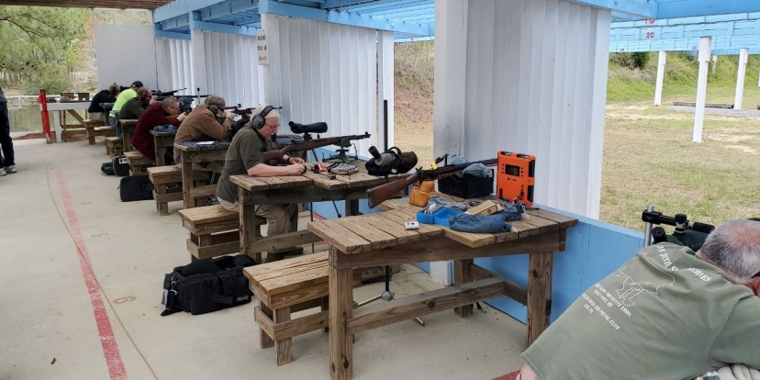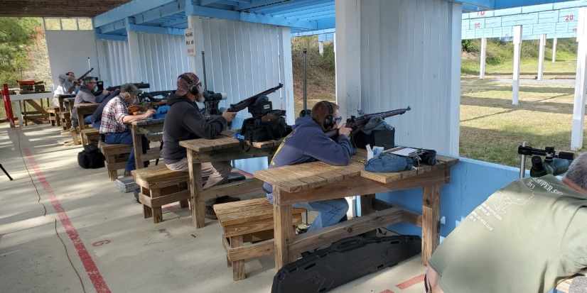

Individual Scores: SR-21 Target 100 yards
Place | Name | Rifle | Caliber | Score | X
1 | Cody Moore | Remington 1903-A3 | .30-06 Springfield | 95 | 2
2 | Paul Stephens | K31 Swiss | 7.5×55mm Swiss | 95 | 1
3 | James Black | M1 Garand | .30-06 Springfield | 94 | 3
4 | James Black | M1 Garand | .30-06 Springfield | 94 | 0
5 | Ron Ferguson | Springfield M1 Garand | .30-06 Springfield | 93 | 2
6 | Ryan Moore | M1 Garand | .30-06 Springfield | 92 | 1
7 | Ron Ferguson | Springfield M1 Garand | .30-06 Springfield | 92 | 1
8 | James Black | M1 Garand | .30-06 Springfield | 92 | 1
9 | Mark Swierczek | 1884 Trapdoor Springfield | .45-70 Government | 91 | 1
10 | Ron Ferguson | Springfield M1 Garand | .30-06 Springfield | 91 | 0
11 | Greg Banta | 1903A3 | .30-06 Springfield | 90 | 1
12 | Mike DiZebba | Springfield M1 Garand | .308 Winchester | 90 | 0
13 | Greg Banta | 1903A3 | .30-06 Springfield | 89 | 2
14 | Paul Stephens | K31 Swiss | 7.5×55mm Swiss | 89 | 0
15 | Ryan Hanneken | Springfield M1 Garand | .30-06 Springfield | 89 | 0
16 | Mike DiZebba | Springfield M1 Garand | .308 Winchester | 88 | 1
17 | Ryan Hanneken | Springfield M1 Garand | .30-06 Springfield | 88 | 1
18 | Ed Thompson | IHC M1 Garand | .30-06 Springfield | 87 | 1
19 | Ed Thompson | IHC M1 Garand | .30-06 Springfield | 87 | 0
20 | Ed Thompson | IHC M1 Garand | .30-06 Springfield | 86 | 0
21 | Ryan Moore | M1 Garand | .30-06 Springfield | 86 | 0
22 | Mark Swierczek | 1884 Trapdoor Springfield | .45-70 Government | 85 | 1
23 | Mark Swierczek | 1884 Trapdoor Springfield | .45-70 Government | 84 | 0
24 | Mike DiZebba | Springfield M1 Garand | .308 Winchester | 83 | 0
25 | Ryan Hanneken | Springfield M1 Garand | .30-06 Springfield | 83 | 0
26 | Greg Banta | 1903A3 | .30-06 Springfield | 82 | 0
27 | Greg Banta | M1 Carbine | .30 Carbine | 81 | 1
28 | Greg Banta | M1 Carbine | .30 Carbine | 81 | 0
29 | Paul Stephens | K31 Swiss | 7.5×55mm Swiss | 80 | 1
30 | Ryan Moore | M1 Garand | .30-06 Springfield | 79 | 0
31 | Cody Moore | Remington 1903-A3 | .30-06 Springfield | 79 | 0
32 | Nathaniel Swift | Turkish Mauser M38 | 8mm Mauser | 78 | 0
33 | Greg Banta | M1 Carbine | .30 Carbine | 76 | 0
34 | Nathaniel Swift | Turkish Mauser M38 | 8mm Mauser | 75 | 0
35 | Cody Moore | Remington 1903-A3 | .30-06 Springfield | 70 | 0
36 | Pat Farrar | M1 Carbine | .30 Carbine | 70 | 0
37 | John Healy | Inland M1 Carbine | .30 Carbine | 59 | 0
38 | Pat Farrar | M1 Carbine | .30 Carbine | 57 | 0
39 | Pat Farrar | M1 Carbine | .30 Carbine | 56 | 0
40 | John Healy | Inland M1 Carbine | .30 Carbine | 56 | 0
41 | John Healy | Inland M1 Carbine | .30 Carbine | 50 | 0
42 | Nathaniel Swift | Turkish Mauser M38 | 8mm Mauser | 34 | 0
* | Steve Reimers | 03 Springfield (modified) | .308 Winchester | 99 | 4
* | Steve Reimers | 03 Springfield (modified) | .308 Winchester | 98 | 4
* | Steve Reimers | 03 Springfield (modified) | .308 Winchester | 98 | 4
*Modified/match rifle, ineligible for competition. 100 points possible. Ties broken by X's and then by fewest hits of lowest value.
Scoring all those targets takes time:
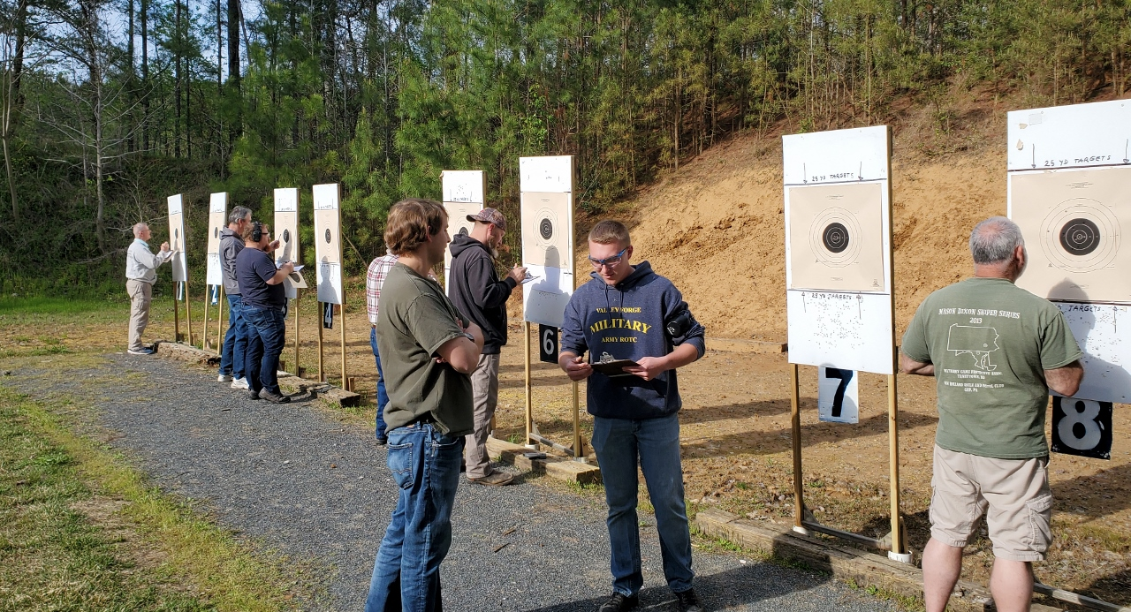

Good looking rifle...too bad it’s ineligible for Woodstock!
