Southern Maryland 2 Gun Winter Match Report
2/17/2024

Attrition. The threat of a little bit of snow was enough to put a dent in the attendance for the first two gun match for 2024! The competitors that showed up were treated to a set of tricky stages with short squads. The call went out to all of those waitlisted to come on out and several did. Some squads were a little light, and equipment issues sidelined a few others but fun was still had by all.

Congratulations
Congratulations to Tim Angers for the overall and Open win with Anibal Delgado just a few seconds back to take first in Prepper. The Lee family swept Ironman with Nicholas coming in first in that division. Josh Gaus took first in Tac-Limited even with challenging rifle targets out at 100 yards. David Metcalfe rounded out the division winners in Tac-Scope.

Included below is the link to the scores posted on Practiscore as well as a couple photos snagged during the match.

https://www.practiscore.com/results/new/233637

Special recognition to Andrea Swierczek for high lady! Great shooting!

The next Southern Maryland Two Gun match will be on July 20, 2024. The heat will be on! Look for the next Carbine Classic on March 30th, 2024. There will

-Jake Swierczek, Anibal Delgado, and Jeremy Hanson

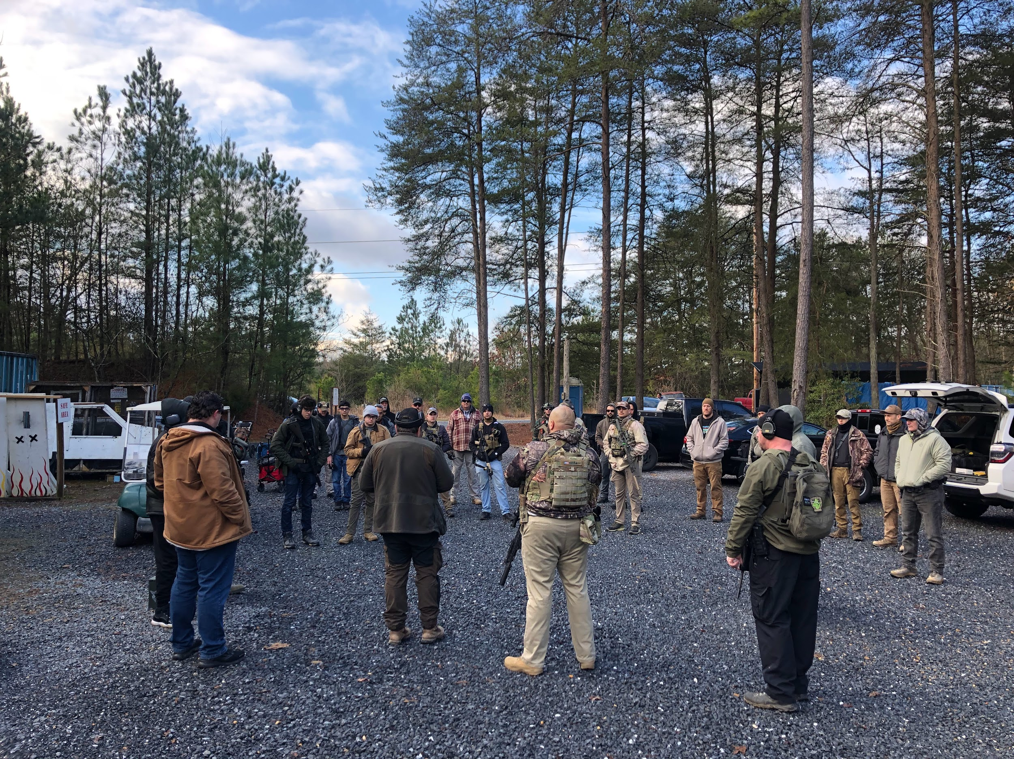
All eyes up for the safety brief.

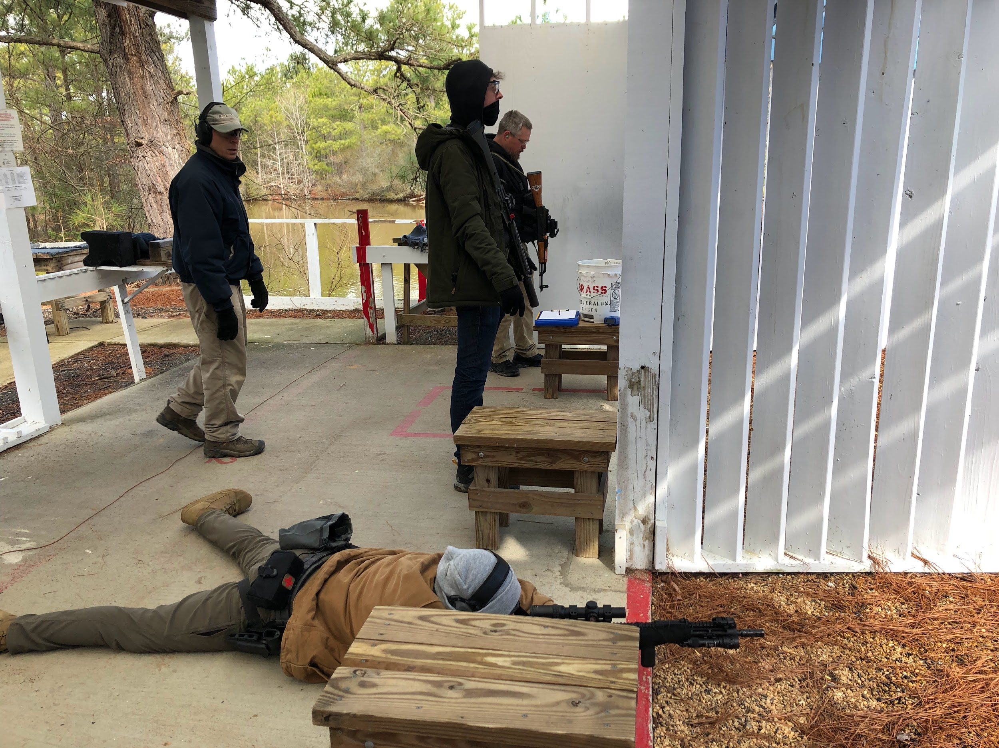
The shooter and the waiters!

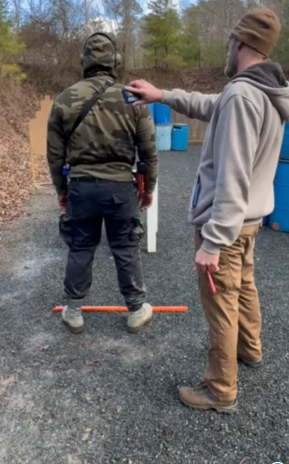
Getting ready to go!

