Sanner’s Carbine Classic December Match Report
12/30/2023
A cool and crisp winter day greeted competitors for the final Sanner’s Carbine Classic Match of 2023. While the time between Christmas and New Years can certainly be busy, 44 dedicated shooters chose to pit themselves and their gear against 5 challenging stages.

Prepper division made a good showing once again with five brave competitors boldly carrying all their equipment for the entire match throughout the morning. While not all of them wore armor this time it is still a drastically different match when shot in kit. If you’ve never tried it, maybe 2024 is your year!

And finally, the true heroes of Ironman division deserve special applause for showing the rest of us eyesight may still be required. Sean even brought out an M1 carbine to show that yes, it too can hang with the best of 1960’s aluminum and polymer.

As the weather stayed cool and the sun peeked above the trees it was David Metcalfe who, despite his unfortunate choice of a PCC came out on top. Great shooting! Category and divisional winners are listed below.

High Categories
High Junior: Joseph Murphy
High Senior: Gary Turner
High Lady: Andrea Swierczek
High Active Duty: John Sterling

Divisional Winners
Dot: Tim Angers
Ironman: Sean Poppert
PCC: David Metcalfe
Prepper: Joe Copenhaver
Scope: John Sterling

Included below is the link for the match results on Practiscore.
https://practiscore.com/results/new/229387

The next match will be on Saturday, March 30th. As usual, look for sign-ups a few weeks in advance.
See you then!

-Jake Swierczek, Jeremy Hanson, and Anibal Delgado

Preppers practice proper positioning:
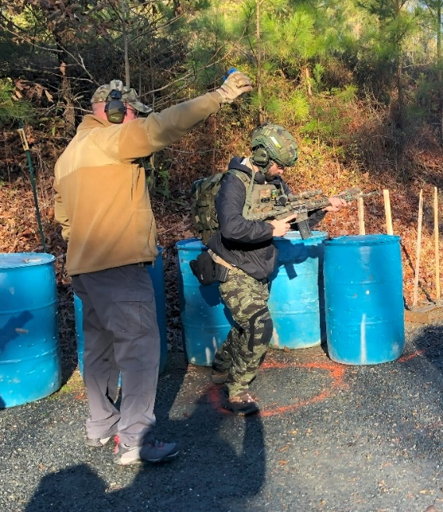
Bonus points for painted nails!
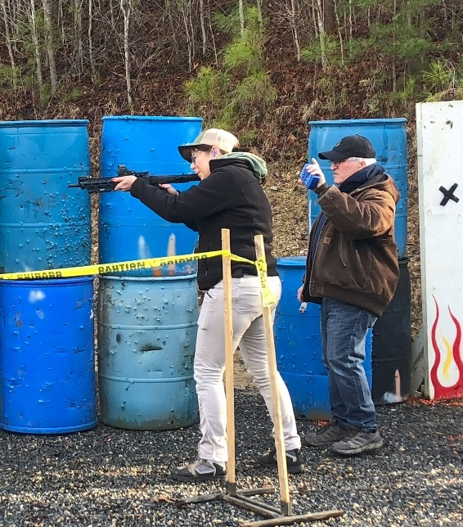
Vintage rifles are not only allowed…
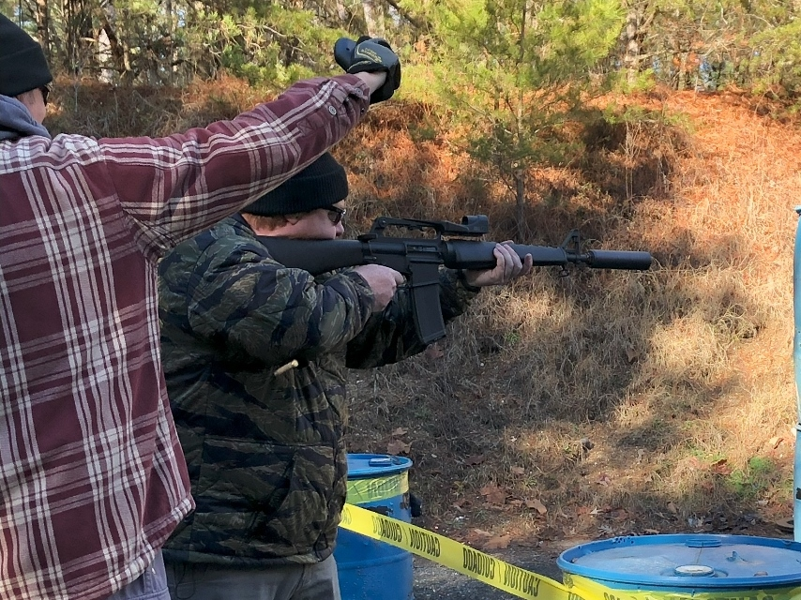

…they’re encouraged!
