Sanner’s Carbine Classic September Match Report
5/6/2023

Shooting a match is always fun, but when the weather cooperates, it’s even better. We couldn’t have asked for a better day for the May 2023 Sanner’s Carbine Classic, the first match of this year’s series.
41 shooters were pitted against five stages featuring a number of challenges. The theme for the match seemed to be “Choose Wisely,” as four stages required competitors to make a decision. Left or right? Prone or standing? Which shoulder? Which way is faster?
The overall winner was Mark Swierczek, who beat his son Jake by a razor-thin 0.64 seconds. The other category and divisional winners are below.
High Categories
High Junior: Paul, Joseph
High Senior: Turner, Gary
High Lady: Swierczek, Andrea
High Active Duty: Craig, Sean

Divisional Winners
Dot: Swierczek, Mark
Ironman: Mund, Joe
PCC: Frank, John
Prepper: Delgado, Anibal
Scope: Bachmann, Aaron

Additionally, special congratulations go to Brad Drouillard for competing with an M1 Carbine and proving that the old girls still rock with a respectable 2nd place finish in Ironman, great shooting!
Included below is the link for the match results on Practiscore.
https://practiscore.com/results/new/202300
As well as an awesome video put together by one of our competitors:
https://www.youtube.com/watch?v=nUyJZZ37Yqg
The next match will be on Saturday, July 29th. As usual, look for sign-ups a few weeks in advance. And a special thank you to Anibal Delgado for helping with this match report; we’ll be seeing much more of him in the future. See you in July!
-Jake Swierczek, Jeremy Hanson, and Anibal Delgado
Showing her Dad how it’s done!
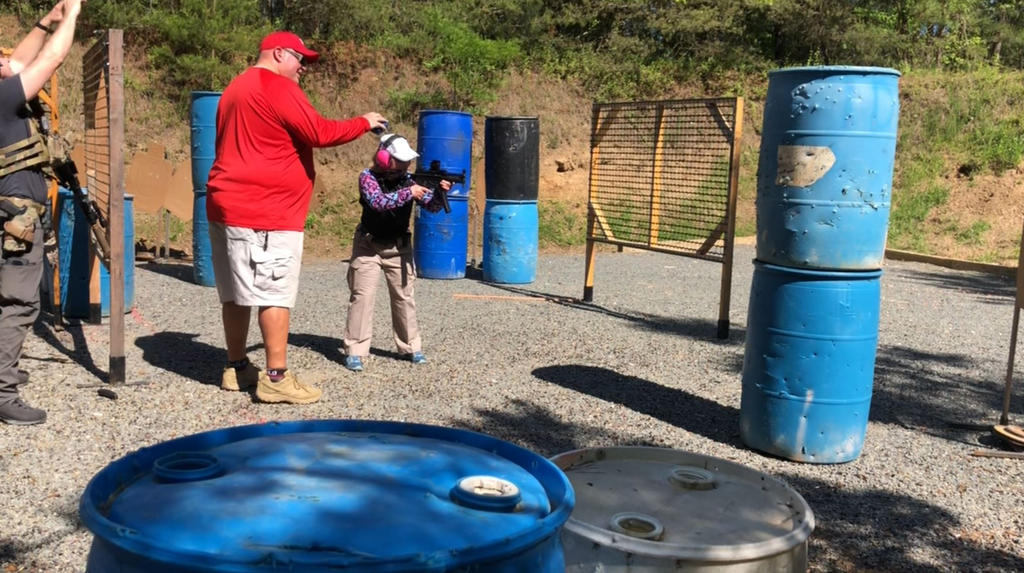
Reloading on the fly:
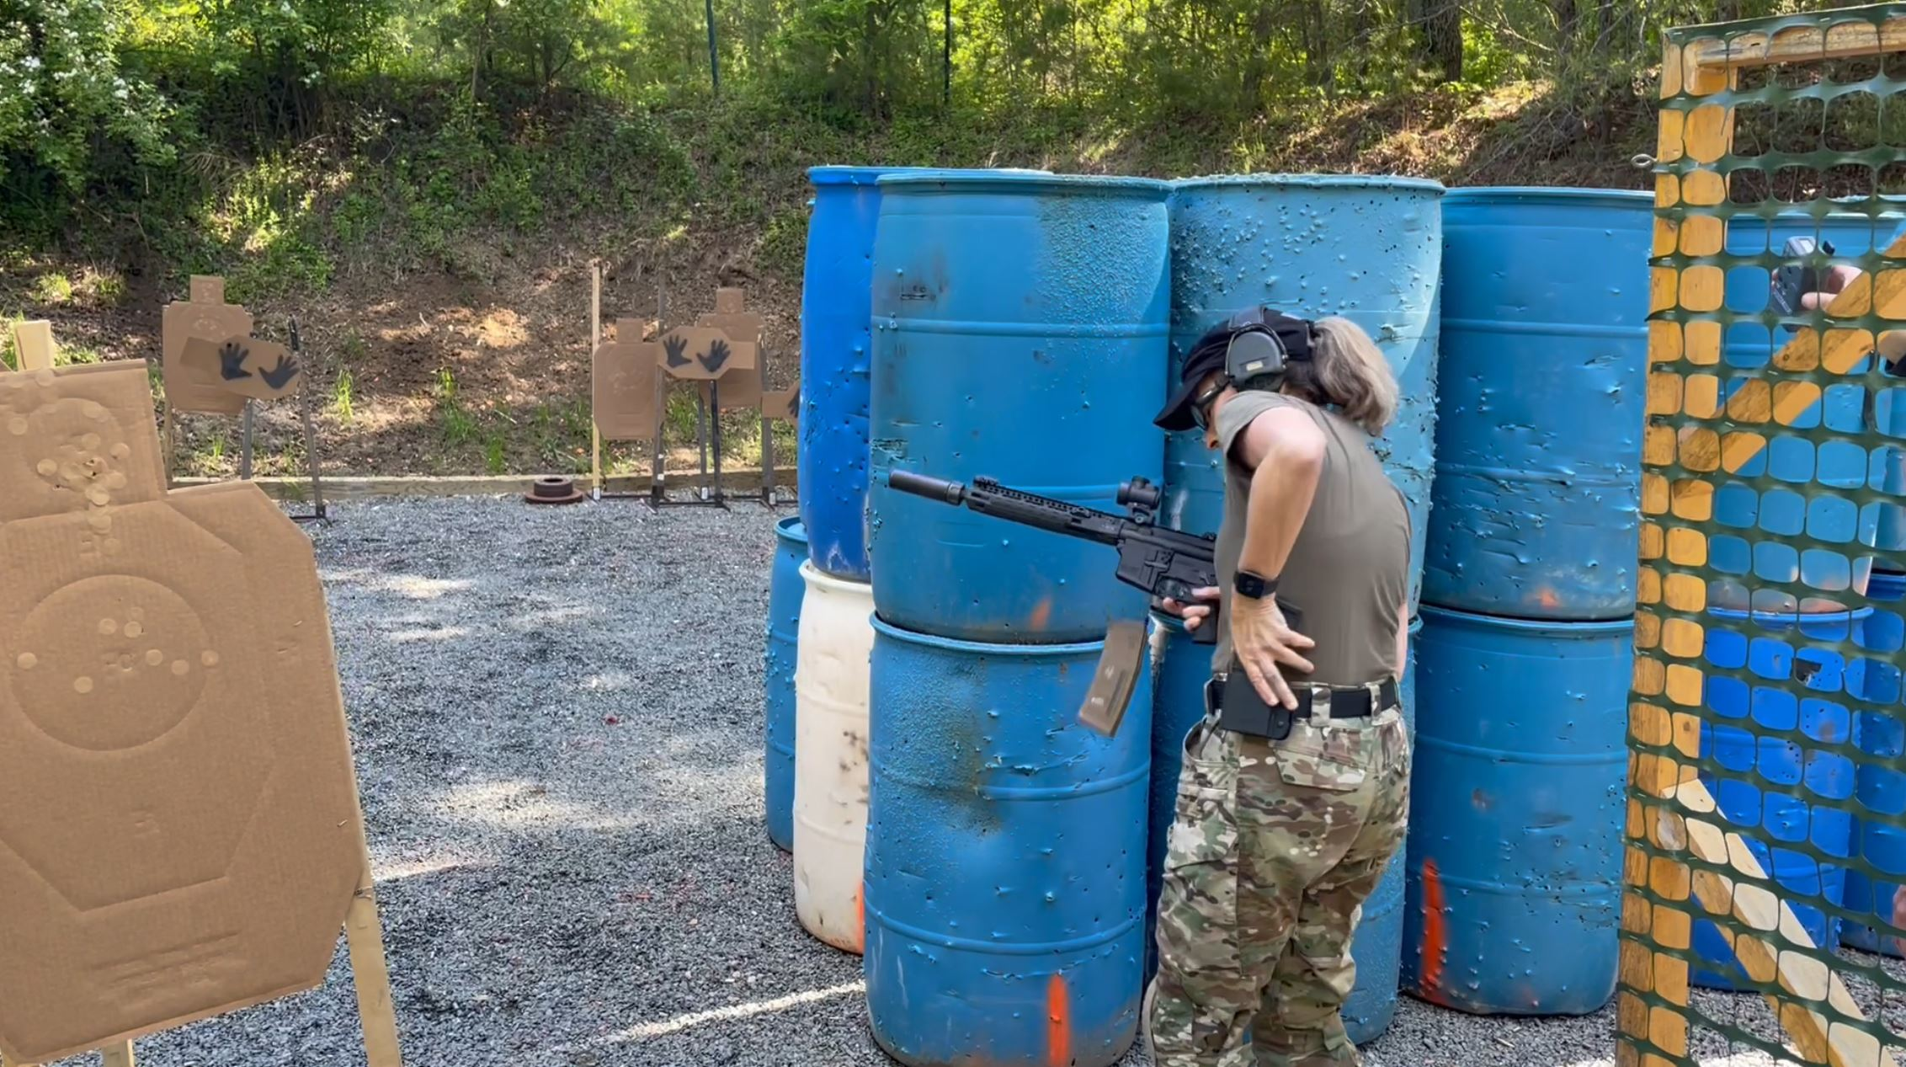

You could go around the wall…
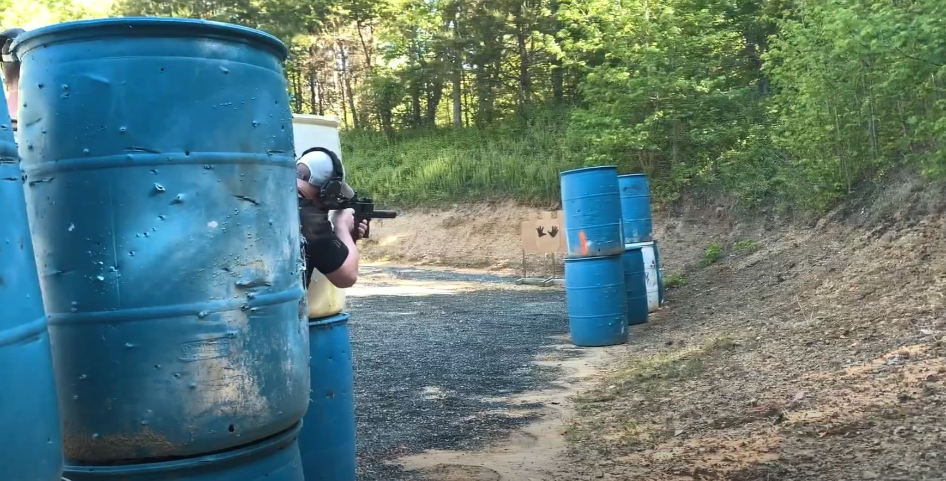
Or you could go under!
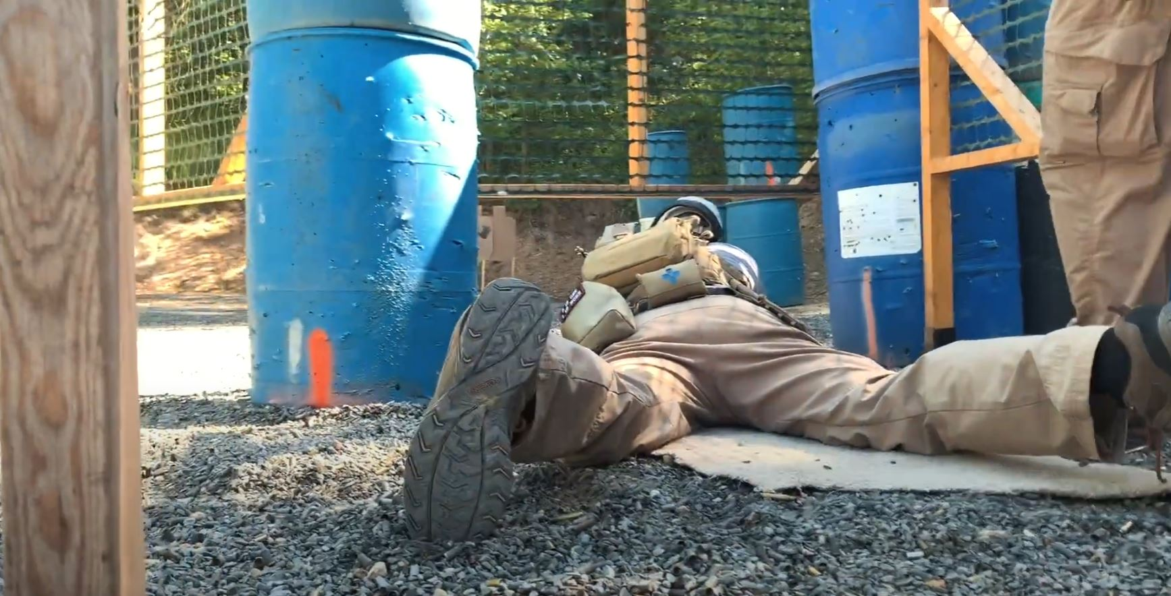

Suppressed fire…
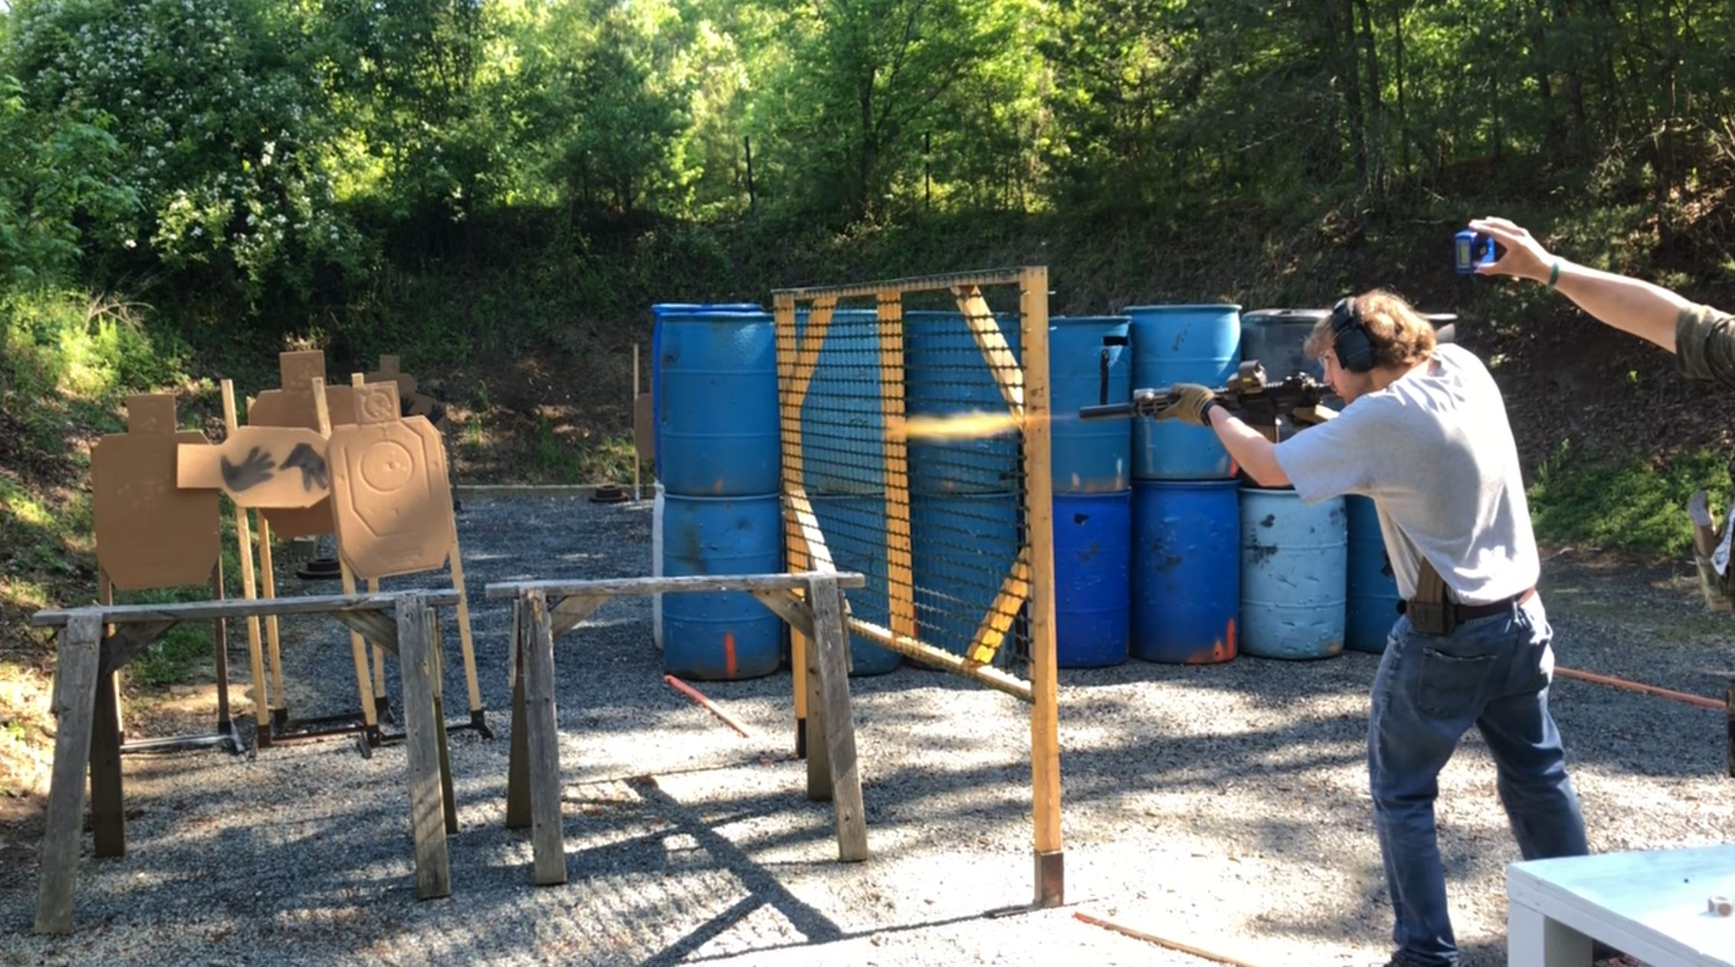
…or unsuppressed, it’s all good!
