Sanner’s Carbine Classic September Match Report
10/30/2021

When the rains cleared from the night before, gorgeous weather greeted competitors on the range for the October Sanner’s Carbine Classic. After a quick setup of all the stages and not too late a start the match was underway with Halloween spirit and gunsmoke in the air.

Stages for this match were all Halloween themed with zombies, poltergeists, and daring candy deliveries being the name of the game. Some stages were focused on the technicalities of shooting a rifle at close and long-ish ranges while others focused on the competitor’s physicality.

As always, those in Prepper pulled their weight as well as their gear, ammo, and rifles. Even on such a cool crisp day the weight and bulk of equipment and costumes is no trivial factor. Congratulations to every Prepper that completed the match, but it was Matt Reider finishing strong, taking first in that category in a costume that involved wearing a gas mask no less!

Included below is the link to the scores posted on Practiscore as well as a couple photos snagged during the match.

https://practiscore.com/results/new/151463

Special recognition must be given to Jack Perrin as the top Active Duty competitor, Gary Turner as the high senior, Andrea Swierczek as the high lady, and finally Jordan Bowling as top Junior! Great shooting!

This concludes the Sanner’s Carbine Classic matches for this year but stay tuned to the Sanner’s website for next year’s match schedule. Until then, keep practicing and we’ll see you next year!

-Jake Swierczek

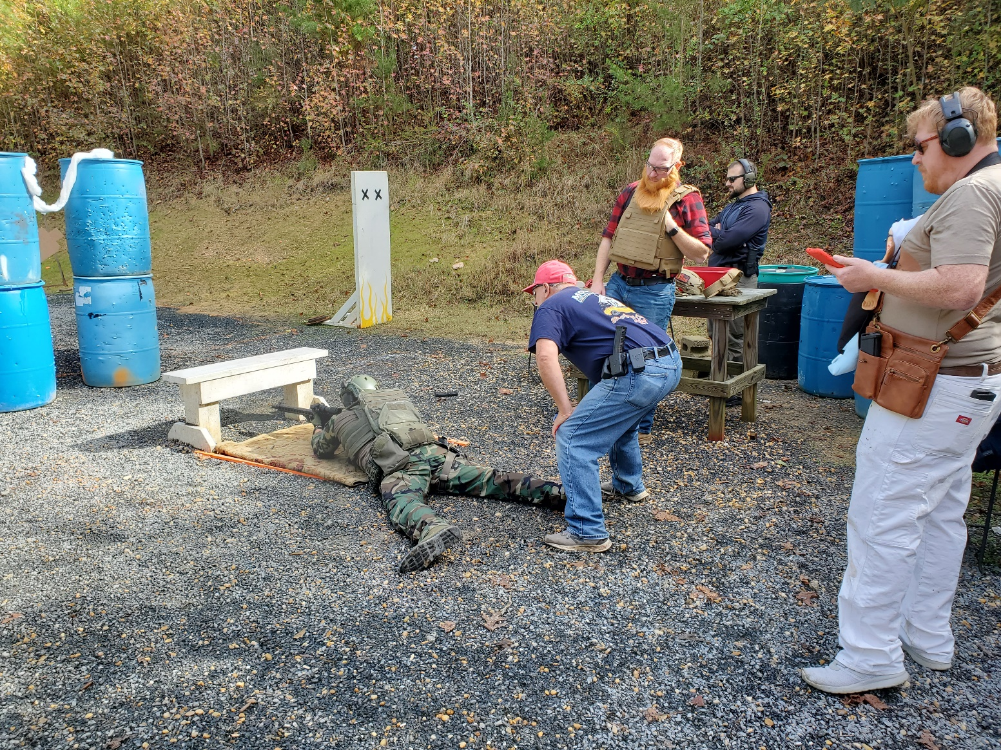
Going prone with kit on can be difficult, but practice makes it easier.

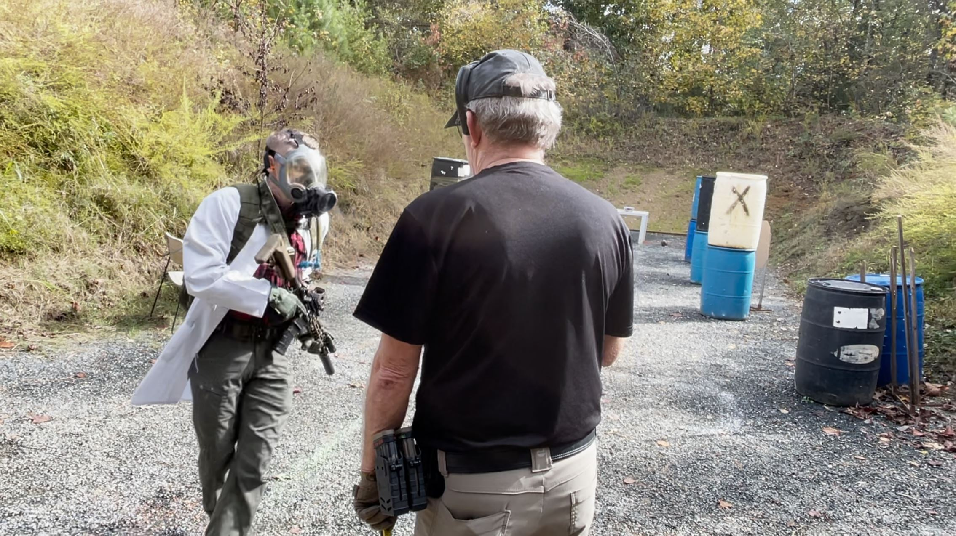
Likewise running in kit can be difficult as well even if that kit is a little more… specialized.
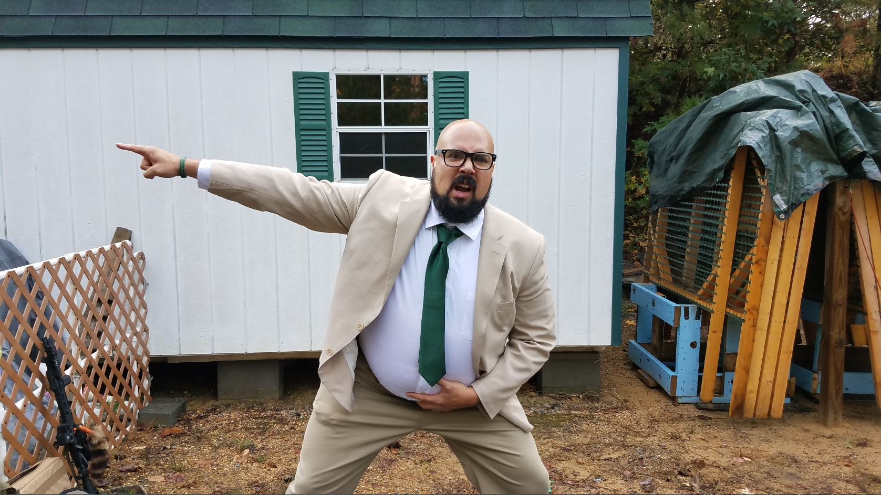

“If you don’t read the entire stage description you’ll end up in a VAN DOWN BY THE RIVER!”

