Sanner’s Carbine Classic September Match Report
9/30/2023

It was a drizzly morning for shooting and the evidence could be seen in the droopy targets presented to the competitors of the September 30th Sanner’s Carbine Classic match. Despite the dreary weather, 38 people came out to test their skills against five challenging stages. This match featured swinging targets and plenty of non-threats to keep you on your toes, even one stage shot entirely from a truck bed (thanks, Jeremy!).

Our overall winner was Jeff Liu, finishing with a blistering final time of just over 105 seconds. A special shout-out is also due to Todd Mullaney who came in 6th overall but also clinched his first win in Prepper division. Congrats to you both! The other category and division winners are as follows:

High Categories
High Junior: n/a
High Senior: Gerry Turner
High Lady: Wendi Brown
High Active Duty: John Sterling

Divisional Winners
Dot: Tim Duehring
Ironman: n/a
PCC: Joe Copenhaver
Prepper: Todd Mullaney
Scope: Jeff Liu

Below is the link for the match results on Practiscore: https://practiscore.com/results/new/220337

Next carbine match is scheduled for Saturday December 30, see you there!

A quick note: if you sign up for this match we expect you to show up and check in before registration closes. If you are signed up and cannot make it for any reason, please withdraw via Practiscore or contact a match director. We usually have a waiting list for these matches and we hate turning people away when a match is full only to then have no-shows.

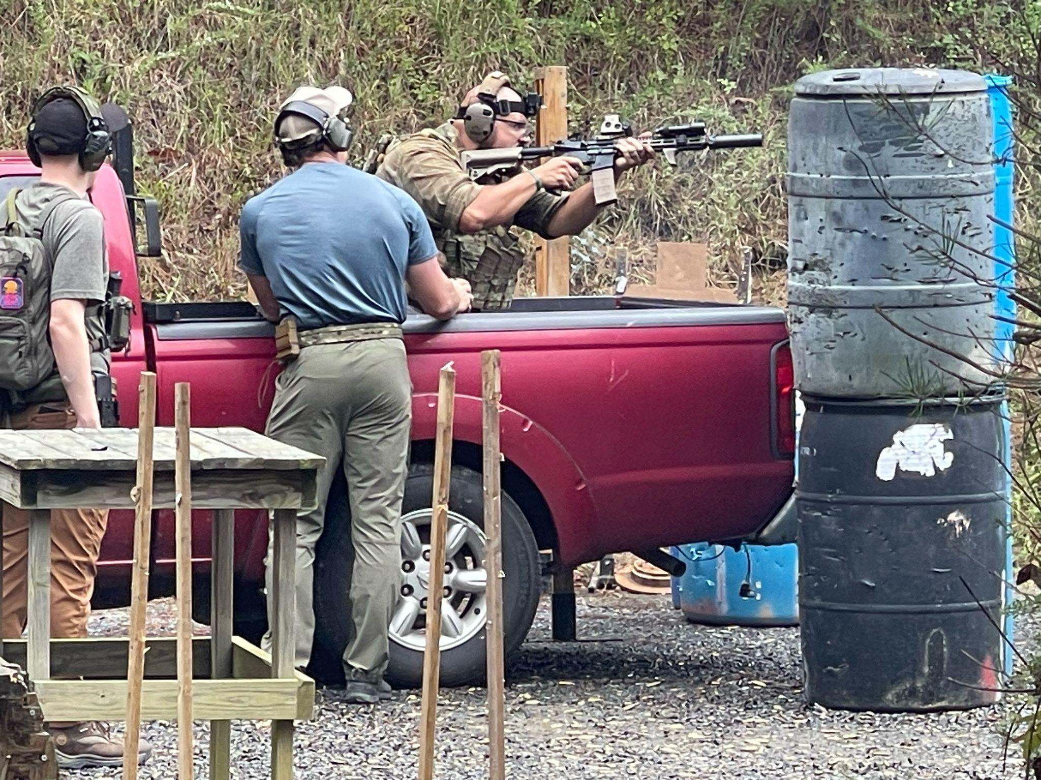
A vehicle stage always leads to good stills
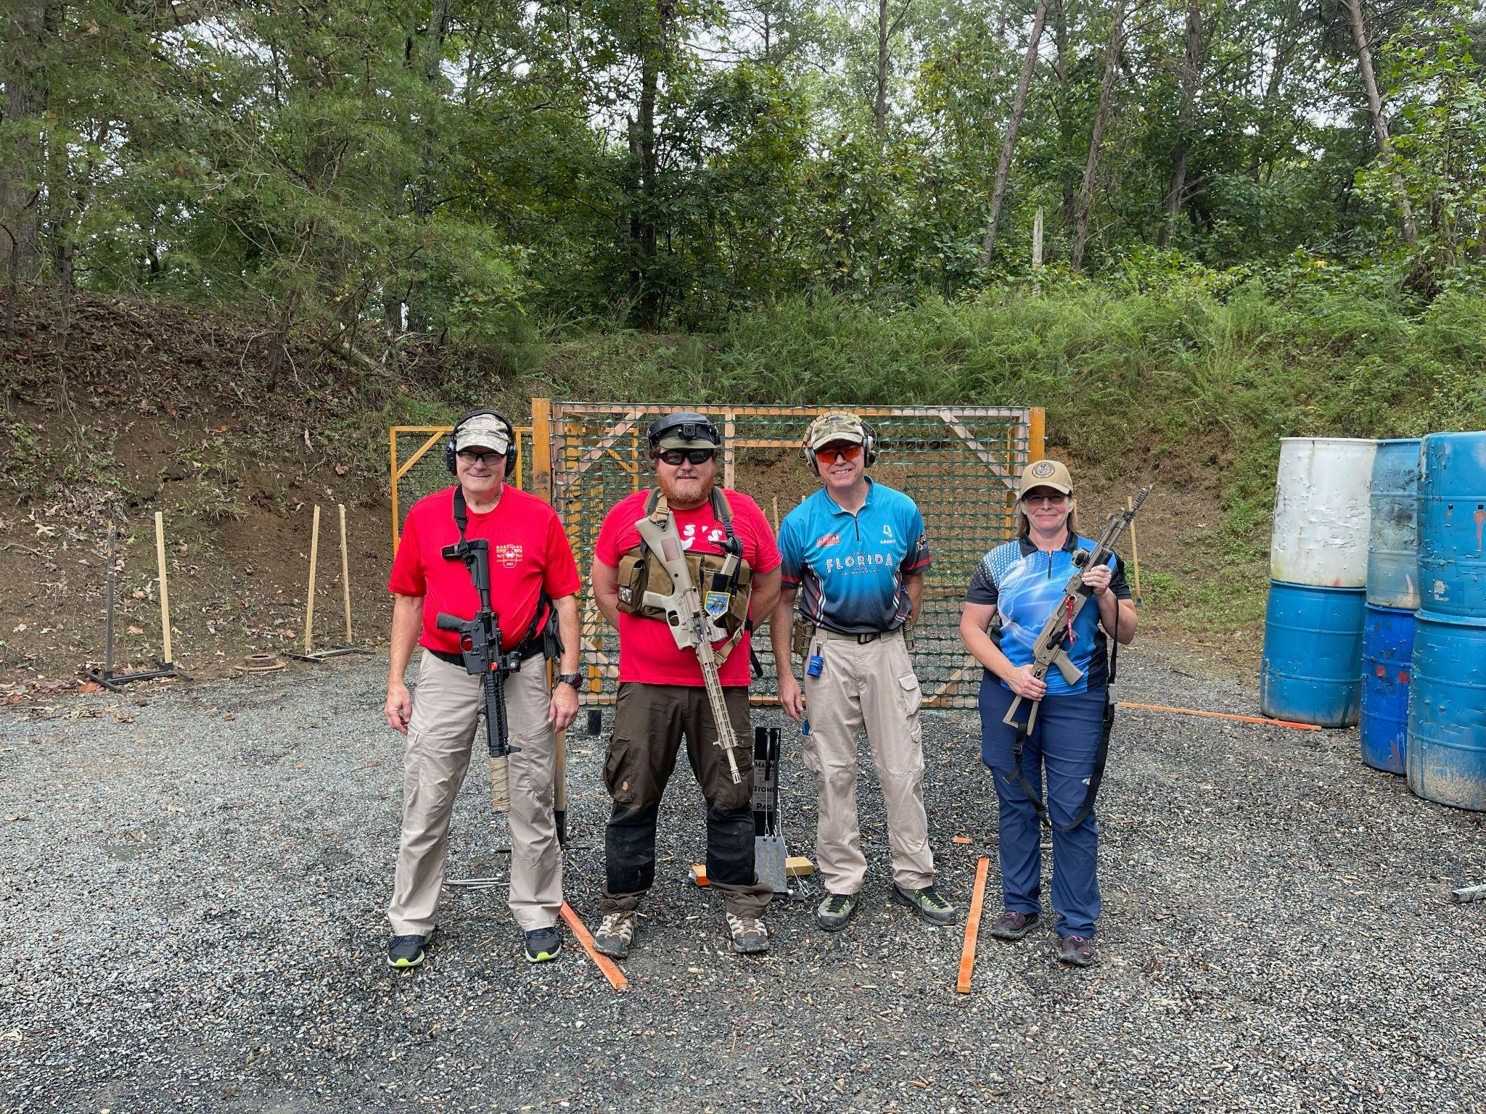
Some happy RSOs after a match well-shot

