Sanner’s Lake IR5050 Rimfire Benchrest Match Report
6 August 2023

Several new faces joined the regulars at the range for the August IR5050-style match at Sanner’s Lake, and in spite of the heat and occasionally gusty winds the scores were impressive from top to bottom! Greg Banta and his Vudoo once again showed everyone how it’s done, setting a new SLSC range record with a high combined score of 747-46X and also equaling his previous best individual string with an outstanding 250-18X, also a range record. Congrats to Greg! Andy Amber kept the heat on the entire time, though, coming in second in the combined category shooting an excellent 737-30X with his Turbo Custom rifle and slick coaxial rest. See all the scores, pictures, and other details below.

Our next match will be on September 3rd; come on out and see if you can break some range records!

Combined Scores:

Place | Name | Rifle | String 1 | X | String 2 | X | String 3 | X | Total | X
1 | Greg Banta | Vudoo V-22S | 250 | 18 | 248 | 16 | 249 | 12 | 747 | 46
2 | Andy Amber | Turbo Custom | 246 | 10 | 246 | 9 | 245 | 11 | 737 | 30
3 | Mark Swierczek | Anschutz 54 MS | 232 | 4 | 244 | 9 | 243 | 5 | 719 | 18
4 | Dave Heilmeier | Anschutz 1903 M64 | 217 | 3 | 203 | 1 | 203 | 0 | 623 | 4
5 | Fran Cox | Ruger 10/22 | 175 | 0 | 196 | 3 | 196 | 3 | 567 | 6
6 | Jeff Heisler | Savage MkII | 186 | 0 | 158 | 1 | Withdrew, balky scope |  | 344 | 1
Note: 750 total points possible. Ties broken by X count.

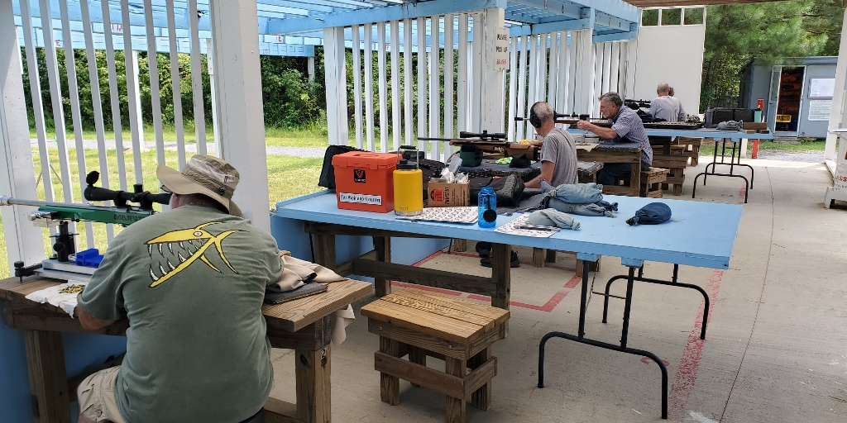

Individual Scores:

Place | Name | Rifle | Score | X
1 | Greg Banta | Vudoo V-22S | 250 | 18
2 | Greg Banta | Vudoo V-22S | 249 | 12
3 | Greg Banta | Vudoo V-22S | 248 | 16
4 | Andy Amber | Turbo Custom | 246 | 10
5 | Andy Amber | Turbo Custom | 246 | 9
6 | Andy Amber | Turbo Custom | 245 | 11
7 | Mark Swierczek | Anschutz 54 MS | 244 | 9
8 | Mark Swierczek | Anschutz 54 MS | 243 | 5
9 | Mark Swierczek | Anschutz 54 MS | 232 | 4
10 | Dave Heilmeier | Anschutz 1903 M64 | 217 | 3
11 | Dave Heilmeier | Anschutz 1903 M64 | 203 | 1
12 | Dave Heilmeier | Anschutz 1903 M64 | 203 | 0
13 | Fran Cox | Ruger 10/22 | 196 | 3
14 | Fran Cox | Ruger 10/22 | 196 | 3
15 | Jeff Heisler | Savage MkII | 186 | 0
16 | Fran Cox | Ruger 10/22 | 175 | 0
17 | Jeff Heisler | Savage MkII | 158 | 1
Note: 250 points possible. Ties broken by X count, then by first target block with highest score.

