The sun was high and the dew point was low making for a very nice day for July in Southern Maryland and three shooters took the opportunity to launch lead at the July rimfire sporter match at Sanner’s Lake. Jake Swierczek started off with a string of personal bests and was on his way to a record-setting performance but a few dropped nines during standing slow fire saw his hopes quickly vanish in a cloud of lead dust. Standing slow fire has a way of doing that. Still good enough for first place, however! Meanwhile Pat Farrar and Tom Reider put together a set of decent scores to come in second and third place, respectively. See all the scores and details below. Next match is on 14 August, see you there!

Optical Sights:

Place | Name | Rifle | Stg 1 | X | Stg 2 | X | Stg 3 | X | Stg 4 | X | Stg 5 | X | Stg 6 | X | Total | X
1 | Jake Swierczek | Savage MkII | 100 | 10 | 100 | 9 | 100 | 6 | 99 | 4 | 96 | 3 | 99 | 6 | 594 | 38
2 | Pat Farrar | Ruger 10/22 | 91 | 2 | 83 | 1 | 84 | 1 | 76 | 1 | 94 | 3 | 87 | 2 | 515 | 10
3 | Tom Reider | CZ 455 American | 72 | 0 | 75 | 0 | 81 | 1 | 85 | 1 | 75 | 0 | 81 | 0 | 469 | 2
600 total points possible. Ties broken by X count.
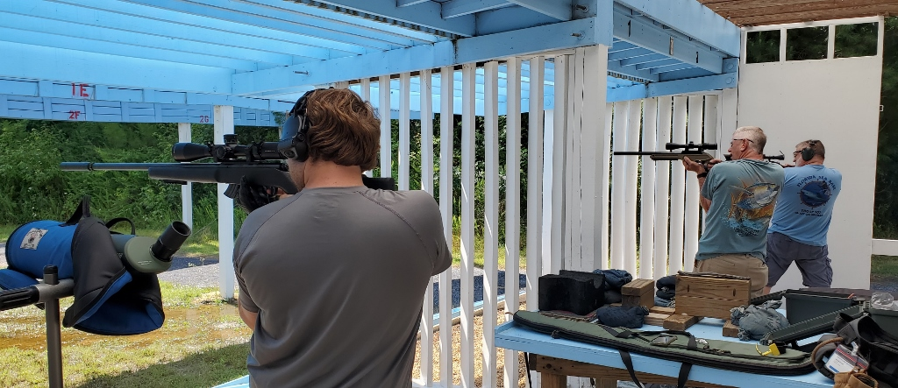

Notes on Rimfire Sporter:
Stage 1 = prone slow fire, 10 shots in 10 minutes, CMP B-19 target at 50 yards
Stage 2 = prone rapid fire, two strings of 5 shots in 30 seconds, CMP B-19 target at 50 yards
Stage 3 = sitting or kneeling slow fire, 10 shots in 10 minutes, CMP B-19 target at 50 yards
Stage 4 = sitting or kneeling rapid fire, two strings of 5 shots in 30 seconds, CMP B-19 target at 50 yards
Stage 5 = standing slow fire, 10 shots in 10 minutes, CMP B-19 target at 25 yards
Stage 6 = standing rapid fire, two strings of 5 shots in 30 seconds, CMP B-19 target at 25 yards

