It was an overcast day at the range, a bit muggy and warmer than usual for October, but it wasn’t raining which prompted an excellent turnout for the October Rimfire Sporter match at Sanner’s Lake. When the smoke cleared it was Matt Reider at the top of the heap with his scoped bolt-action CZ 455 American, scoring a personal best 580-17X. Right behind him was Jake Swierczek showing that you don’t need a scope to do well in this match, scoring an excellent 573-13X with his notch-and-post iron-sighted bolt-action CZ 452 Ultra Lux. Greg Banta with his Nordic upper on a tried-and-true AR lower re-entered the match on the second relay and managed to tie his score on the first relay (although he nearly doubled his X-count), with a solid 538-11X being good enough for third place, just squeaking ahead of Brian Basenback and his 10/22 by one point!
See all the scores and details below. Last match of the year is on November 13th, and the weather promises to be cool and crisp by then (finally!).
See you there!

Place | Name | Rifle | Sights | Prone  Slow | X | Prone  Rapid | X | Sitting  Slow | X | Sitting  Rapid | X | Standing  Slow | X | Standing  Rapid | X | Total | X
1 | Matt Reider | CZ 455 American | Scope | 99 | 5 | 97 | 3 | 99 | 3 | 94 | 2 | 96 | 2 | 95 | 2 | 580 | 17
2 | Jake Swierczek | CZ 452 Ultra Lux | Irons | 98 | 3 | 94 | 1 | 95 | 2 | 94 | 2 | 95 | 2 | 97 | 3 | 573 | 13
3 | Greg Banta (reentry) | Nordic 22 AR upper | Dot | 96 | 6 | 95 | 3 | 86 | 1 | 84 | 0 | 88 | 1 | 89 | 0 | 538 | 11
4 | Greg Banta | Nordic 22 AR upper | Dot | 95 | 1 | 88 | 1 | 91 | 2 | 85 | 1 | 90 | 1 | 89 | 0 | 538 | 6
5 | Bryan Basenback | Tactical Solutions 10/22 | Scope | 94 | 1 | 89 | 0 | 89 | 0 | 90 | 0 | 88 | 0 | 87 | 0 | 537 | 1
6 | Pat Farrar | Ruger 10/22 | Scope | 93 | 0 | 88 | 0 | 83 | 0 | 85 | 0 | 85 | 0 | 77 | 0 | 511 | 4
7 | James Butchko III | Mossberg 715T Plinkster | Scope | 87 | 1 | 88 | 0 | 87 | 1 | 79 | 2 | 80 | 1 | 86 | 0 | 507 | 5
8 | James Butchko Jr. | Ruger 10/22 | Scope | 86 | 1 | 87 | 0 | 86 | 2 | 81 | 0 | 92 | 2 | 62 | 2 | 494 | 7
9 | Tom Reider | CZ 455 American | Scope | 83 | 0 | 67 | 0 | 83 | 1 | 61 | 0 | 72 | 0 | 75 | 2 | 441 | 3
600 total points possible. Ties broken by X count.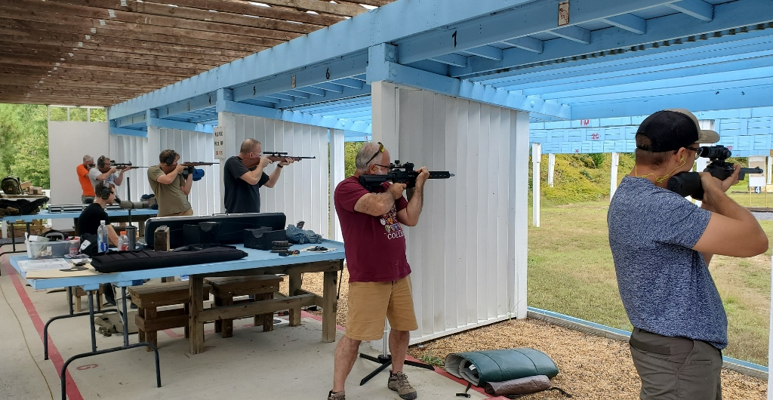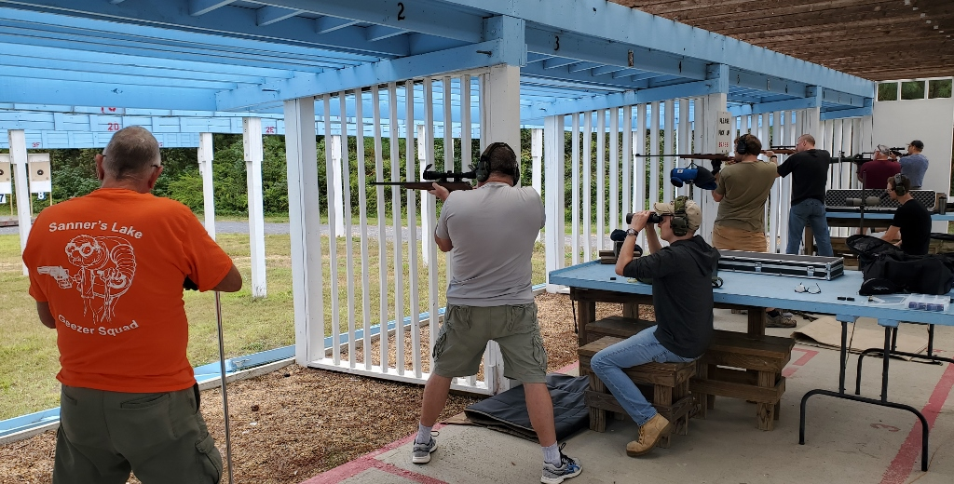

Notes on Rimfire Sporter:
Stage 1 = prone slow fire, 10 shots in 10 minutes, CMP B-19 target at 50 yards
Stage 2 = prone rapid fire, two strings of 5 shots in 30 seconds, CMP B-19 target at 50 yards
Stage 3 = sitting or kneeling slow fire, 10 shots in 10 minutes, CMP B-19 target at 50 yards
Stage 4 = sitting or kneeling rapid fire, two strings of 5 shots in 30 seconds, CMP B-19 target at 50 yards
Stage 5 = standing slow fire, 10 shots in 10 minutes, CMP B-19 target at 25 yards
Stage 6 = standing rapid fire, two strings of 5 shots in 30 seconds, CMP B-19 target at 25 yards

