Sanner’s Lake Woodstock Match Report – April 2023

Five shooters made it to the range on a balmy spring afternoon to do battle at the April Woodstock match at Sanner’s Lake, and it was a neck-and-neck battle for the top spot as the scores came right down to the wire! But when the smoke (and pollen) cleared, Ron Ferguson and his Garand squeaked out the win over Greg Banta and his ’03 by a single point, finishing up with an excellent 278-3X combined score over Greg’s super 277-2X. Right behind them, Jonathan Ramsey reached deep into his gun safe and dragged out his FN-49 and showed that it could easily keep up with the regulars, notching a strong 269-1x to take third place overall.

See all the scores and details below. Thanks to everyone who came out and helped set up for the match and put everything back together afterwards. The next Woodstock match is on May 18th; grab your vintage war relic and join us at the range!

Combined Scores:

SR-21 Target 100 yards
Place | Name | Rifle | String1 | X | String2 | X | String3 | X | Total | X
1 | Ron Ferguson | Springfield M1 Garand | 88 | 0 | 94 | 2 | 96 | 1 | 278 | 3
2 | Greg Banta | 1903 Springfield | 89 | 0 | 94 | 0 | 94 | 2 | 277 | 2
3 | Jonathan Ramsey | FN-49 | 90 | 0 | 91 | 0 | 88 | 1 | 269 | 1
4 | Paul Stephens | Swiss K31 | 80 | 0 | 75 | 1 | 84 | 0 | 239 | 1
5 | John Healy | No.4 Mk1 Long Branch | 69 | 0 | 69 | 0 | 42 | 0 | 180 | 0
300 total points possible. Ties broken by X's and then by highest individual string.

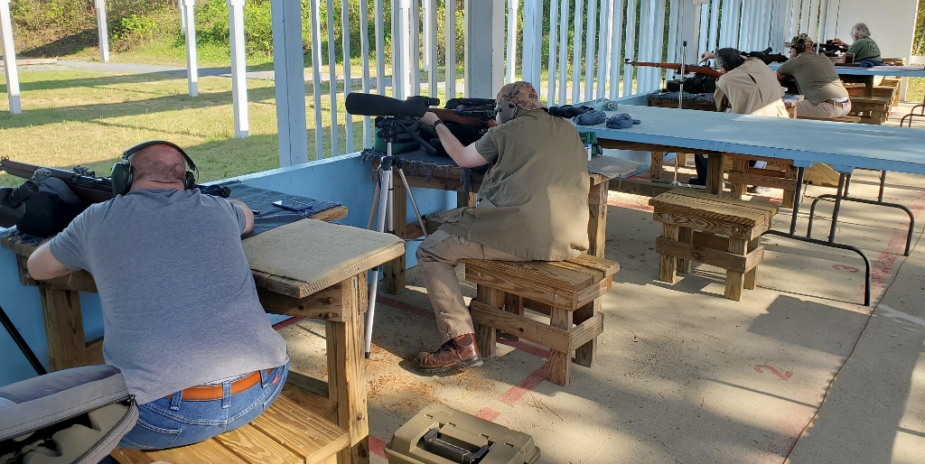

Individual Scores:
SR-21 Target 100 yards
Place | Name | Rifle | Caliber | Score | X
1 | Ron Ferguson | Springfield M1 Garand | .30-06 Springfield | 96 | 1
2 | Greg Banta | 1903 Springfield | .30-06 Springfield | 94 | 2
3 | Ron Ferguson | Springfield M1 Garand | .30-06 Springfield | 94 | 2
4 | Greg Banta | 1903 Springfield | .30-06 Springfield | 94 | 0
5 | Jonathan Ramsey | FN-49 | 8mm Mauser | 91 | 0
6 | Jonathan Ramsey | FN-49 | 8mm Mauser | 90 | 0
7 | Greg Banta | 1903 Springfield | .30-06 Springfield | 89 | 0
8 | Jonathan Ramsey | FN-49 | 8mm Mauser | 88 | 1
9 | Ron Ferguson | Springfield M1 Garand | .30-06 Springfield | 88 | 0
10 | Paul Stephens | Swiss K31 | 7.5×55mm Swiss | 84 | 0
11 | Paul Stephens | Swiss K31 | 7.5×55mm Swiss | 80 | 0
12 | Paul Stephens | Swiss K31 | 7.5×55mm Swiss | 75 | 1
13 | John Healy | No.4 Mk1 Long Branch | .303 British | 69 | 0
14 | John Healy | No.4 Mk1 Long Branch | .303 British | 69 | 0
15 | John Healy | No.4 Mk1 Long Branch | .303 British | 42 | 0
100 points possible. Ties broken by X's and then by fewest hits of lowest value.

