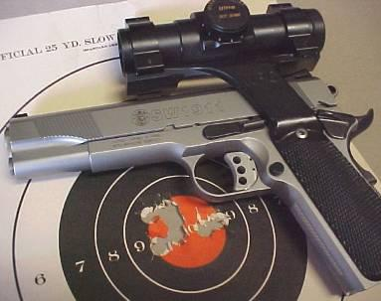
Sanner’s Lake Sportsmen’s Club
Precision Pistol
Match Rules and Information
Version 1.0, Revision 0, dated May 2016

Match Director(s): John Mountjoy / ________________
mountjoyjw@yahoo.com / (301) 904-6156

Purpose: To provide an entry-level precision pistol program at Sanner’s Lake Sportsmen’s Club. See figure 1 for the match publicity flyer.

General Layout and Scoring:
Generally IAW NRA Precision Pistol Rules using the “NRA Short Course” course-of-fire, except as amended per this document.
Participant Eligibility: Open to the general public, including any non-prohibited individuals.
Individuals of less than 21 years of age must have documented prior pistol match shooting experience or have completed a NRA Basic Pistol course and have a parent or guardian present during the competition. It is recommended that novice shooters over 21 years of age complete the NRA Basic Pistol Course.

Range Facilities / CoF Overview:
Facilities/Location: This match is fired on the Club’s 50-yard Bullseye-Range with targets set at 25 yards. Lanes 1-4 are reserved for this event.
Course of Fire: Ten minute unlimited practice.
Slow Fire: 2 five shot strings on B-16 target in 10 minutes. Shooters reload on their own.
Timed Fire: 2 five shot strings on B-8 target in 20 seconds per string. Shooters reload on command.
Rapid Fire: 2 five shot strings on B-8 target in 10 seconds per string. Shooters reload on command.

Pistol Categories:

.22 caliber Semi-Automatic Pistol or Revolver - Any pistol, semi-automatic or revolver, using a .22 caliber rim-fire cartridge having an overall length of not more than 1.1 inches and with lead or alloy bullet not greater than .23 inches in diameter and weighing not more than 40 grains; barrel length, including cylinder, not more than 10 inches. Firearm must have a capacity of at least 5 rounds. Trigger pull not less than 2 pounds.
Any sights, including telescopic, are permitted with the exception of those sights that project an image on the target. Open sights may be adjustable but not over 10 inches apart measured from the apex of the rear sight to the apex of the front sight. Any sighting device programmed to activate the firing mechanism is prohibited. All standard safety features of the firearm must operate properly.

Any Centerfire Semi-Automatic Pistol or Revolver - Centerfire pistols, semi-automatic or revolvers of .30 caliber or larger (including 7.62 mm, 7.65mm and .45 caliber pistols and revolvers); barrel length, including cylinder, not more than 10 inches; trigger pull not less than 2 1/2 pounds, except.45 caliber semiautomatic pistols not less than 3 1/2 pounds. Firearm must have a capacity of at least 5 rounds.
Any Sights, including telescopic, are permitted with the exception of those sights that project an image on the target. Open sights may be adjustable but not over 10 inches apart measured from the apex of the rear sight to the apex of the front sight. Any sighting device programmed to operate the firearm automatically is prohibited.

Any .45 Caliber Semi-Automatic Pistol or Revolver – Any .45 caliber semi-automatic pistol or revolver; barrel length, including cylinders, not more than 10 inches, trigger pull for revolvers not less than 2 1/2 pounds, .45 caliber semi-automatic pistol trigger pull not less than 3 1/2 pounds. Firearm must have a capacity of at least 5 rounds.
Any sights, including telescopic, are permitted with the exception of those sights that project an image on the target. Open sights may be adjustable but not over 10 inches apart measured from the apex of the rear sight to the apex of the front sight.
Any sighting device programmed to activate the firing mechanism is prohibited. All standard safety features of firearm must operate properly.

Additional Firearm Restrictions: Programs may specify particular calibers of types of center-fire guns that will be permitted or not permitted in each stated event.

Other Match Rules and Restrictions:
• Ear and Eye protection required.
• Any safe ammunition that meets SLSC rules is allowed.
• Either the one-handed or the two-handed pistol grips may be used.
• Start command will only be given once all shooters have signaled loaded and ready.
• Shooter may only participate in each class once per event
• No more than 5 rounds of ammunition in the firearm at any time

Entry Fee:
• General Entry Fee: $10
• SLSC-Members and youths (under 18): $5
• Active-Duty Military and Disabled Veterans: FREE
• RO and match staff shoot for free. As this is not a formally sanctioned or registered NRA match, the Match-Director IS allowed to shoot in the match.

If any shooter wishes to shoot more than one match or multiple classes this is permissible so long that all other shooters have been allowed to shoot first. In this case, the cost will be only $5 over the first relay; this is for both members and non-members.

Scoring, Recognition, and Prizes:

Scoring is performed IAW NRA rules.

Medallion given to overall match-winners.
All participants are recognized in the match-report based upon their individual scores.
• Bronze level recognition 240-259 points
• Silver level recognition 260-279 points
• Gold level recognition 280-300 points

Winners are recognized for all firearms classes/types and special recognition categories. The overall match-winner is also recognized for the “3-Gun Aggregate” but must shoot both a semi-automatic pistol and a revolver in order to qualify.

Scorecards are shown in figure 2.

Recognition is given in the match-report to top-scorers in all categories/classes and special-recognition categories. Scores and placements will be produced in a “Match Bulletin” posted on the MDShooters.com forum and/or on the Sannerslake.org website.

Firearms / Shooter Classes:
One-handed, iron-sights are the default for this match.
Iron-Sights: Traditional iron-sighted firearms.
Optics: All firearms with non-iron (telescopic, holographic, red-dot, etc.) sights will fall into this category. Devices that project an image onto the target are not permitted. If the shooter uses optics in shooting ANY of his/her strings, then the entire CoF is recorded/scored as two-handed.
One-Handed: For shooters using the traditional bullseye-style one-handed shooting stance.
Two-Handed: For shooters using any form of two-handed stance. If the shooter uses this stance in shooting ANY of his/her strings, then the entire CoF is recorded/scored as two-handed.
Special Recognition Classes:
Junior: Aged 12 or younger.
Youth: Aged 13-17
Lady: Female
Senior: Aged 65+

General Rules
Safety As with all events at SLSC, eye and ear protection is mandatory at all times on the range. Wraparound-style safety glasses or ballistically-safe shooting-glasses with sideshields are mandatory for all personnel within line-of-sight of either the shooters or the target-pins. The range safety officer calling the match will inspect the line prior to allowing anyone to proceed downrange and will also inspect the range before going hot. When cold, all actions must be locked open and all magazines removed from the guns. Chamber flags are preferred. Once the line is called cold, no one may touch any firearm under any circumstance.

ALWAYS PRACTICE PROPER MUZZLE CONTROL: Pay special attention to muzzle position during magazine-changes. Muzzle must remain pointed at the downrange berm. The RO shall call “MUZZLE!” to indicate a violation.

ALWAYS PRACTICE PROPER TRIGGER DISCIPLINE: Fingers must remain off the trigger and outside the trigger-guard during initial loading and making-ready of the gun, during the start-position, and during re-loads. The RO shall call “TRIGGER!” to indicate a violation.

Anyone violating safety rules will be disqualified from the match, and their money will not be refunded. Generally (but not always), the first “TRIGGER!” or “MUZZLE!” call made by the Range Safety Officer will not disqualify a shooter unless it is significant. However, the second “TRIGGER!” or “MUZZLE!” call will result in a disqualification of the shooter. Whenever a formal warning is made then annotation “F” or “T” is made upon the shooter’s scorecard. When disqualified, “DQ” is annotated on the scorecard.
Transportation of All Firearms: SLSC is a cold-range. All firearms will be unloaded with the firearm either secured within an enclosed case/bag or holstered. ECIs are recommended and will be provided by the Club, if needed. The firearm will not be loaded until the shooter is on the line and the command to “Load and make ready!” is given.
Safe Area: A safe-area shall be made available where firearms may be handled, un-cased and holstered. No ammunition shall be allowed within the safe area.
Reloading Magazines Shooters are encouraged to reload magazines and speed loaders while the range is cold to speed the progression of the match. Obviously, you cannot handle or load firearms while the range is cold. Magazines may be handled/loaded behind the firing-line.
Capacity Restrictions There are no capacity restrictions for semi-automatics or revolvers beyond that each firearm must hold at least five rounds.
Reshoot Strings: Reshoot strings are only reshot for range failures. If your target falls off of the frame or if there is a timer failure you may reshoot the string. Reliability of your firearm is part of the game and there are no reshoots for guns that jam or otherwise fail.
Starting Position: Once the range is called hot, shooters may load rounds into chambers, safeties off, and cocked hammers. FINGERS MUST BE OUTSIDE OF THE TRIGGER-GUARDS AND OFF OF TRIGGERS. Shooters will start with pistol in hand from the low ready position.
Cease Fire: A cease fire may be called by any shooter whether on the line or as a spectator. Upon the call of a cease fire all shooters shall immediately stop firing, keep the firearm pointed down range and wait for further instructions from the RSOs.
Spectators: Spectators shall remain behind the firing line while relays are in progress.
Target Guidelines: B-8 and B-16 targets shall be used, installed on static target-frames. No turning target-frames shall be used.

Match Commands:
Shooters to the Line - At this command, the shooter will take his place at the firing line. Firearms are carried to the line unloaded either holstered or cased/bagged.

Shooters Load and Make Ready- At this command, the shooters will load their firearm and stand in the ready position. The ready position consists of the shooter standing, facing the pins, in the low ready position.

Shooters, Stand By. When the signal (beep from shot-timer, or tactile from RO if requested by shooter) from the RO, the shooters may engage the targets and commence firing.

When the Cease Fire is called, shooters will immediately stop firing and wait for the next command. If a shooter has cleared the table, that shooter will stop. The shooter may also decide to cease firing before clearing the table, and shall communicate this to the RO.

If Finished, Unload and Show Clear. Upon hearing this command each shooter will unload their firearm, remove the magazine or open the cylinder and show the range official an empty firearm including the chamber.

If Clear, Hammer-Down and Holster, Bag, or Case: The official shall confirm that a safe and unloaded firearm exists shall authorize the shooter to then bag, case, or holster their unloaded firearm.

The Line is Clear. Shooters May Go Forward Score and Replace Targets – This command is issued only after the unloaded firearm is securely bagged, cased, or holstered. At this time the shooters will go downrange to the targets and score and replace the targets. At the discretion of the Match-Director, shooters may be permitted to score each-others’ targets but not their own. During this time period while shooters are down range, absolutely no firearm shall be handled by anyone.
Time Commitment: This is planned as a weekday afternoon match, running from 4 PM until 6 PM. A safety-briefing will be given at the start of each match, as well as before each relay as necessary. See figure 3 for estimated timing for a stage. Each stage should take approximately an hour.

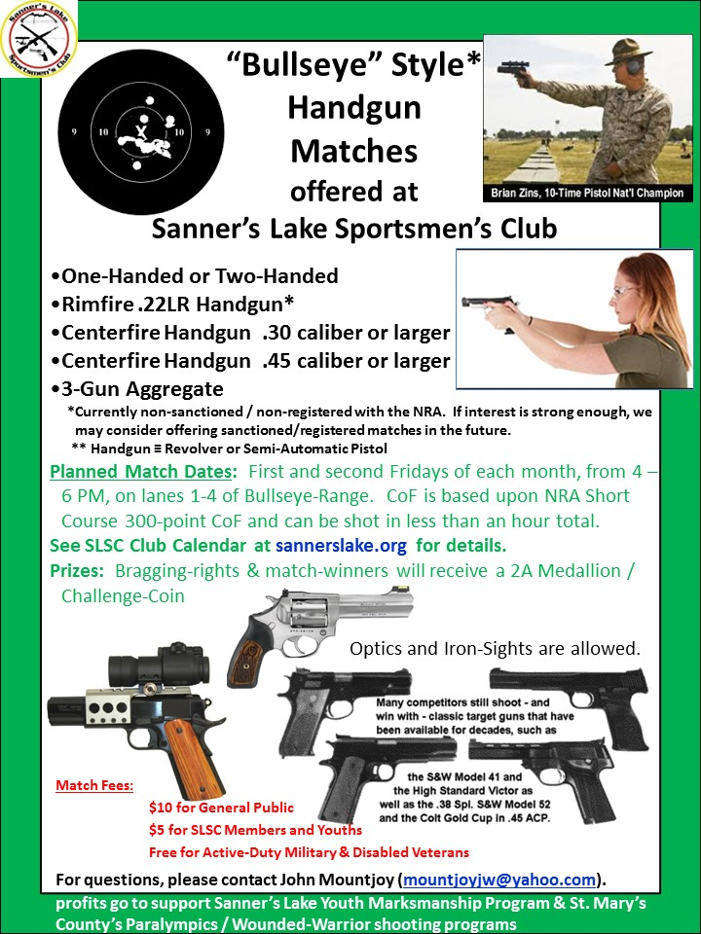
Figure 1: Match Flyer
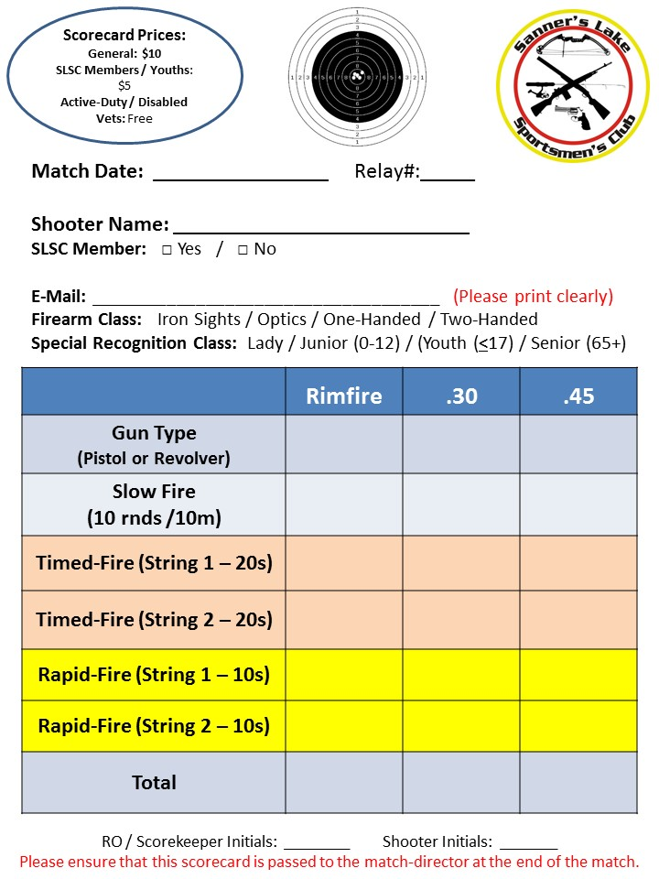
Figure 2: Scoresheet

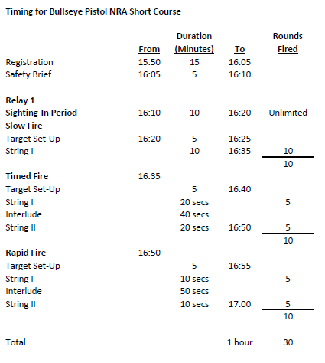
Figure 3: Estimated Match Timing

